Make-up Assignment

A Tennis Court is comprised of numerous lines and areas. Label the court below:

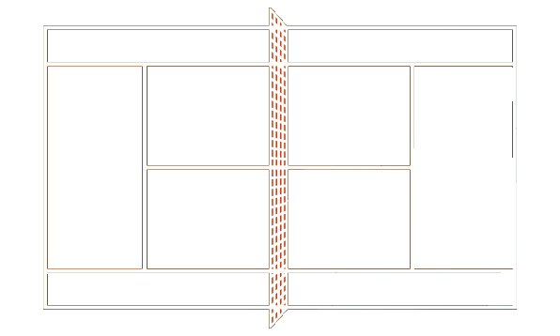
Area 6
Area 7
Area 8
1
2
3
4
5

- ________________________________________________________
- ________________________________________________________
- ________________________________________________________
- ________________________________________________________
- ________________________________________________________
- ________________________________________________________
- ________________________________________________________
- ________________________________________________________

