# 

* Planners are a good way to communicate back and forth with teachers
* Work with students to mark ahead what days of the school schedule fall on what day
* Keep a paperclip inside to bookmark the right page
* Homework is written in the school planners daily – this should be used as a “to-do” list when students are home at night.
* Homework is expected to be complete on the day it is due
* Please relay any issues about HW to the teacher through notes or email – we want to make sure we can review what students do not understand
* 6-8th Students get one resource period a day, however, this is not simply for HW, we take time to review and break down concepts students do not understand.
* 6-8th Students also get a Study Hall once per 4-day rotation that they can use to get ahead or catch up on any work

# Planners & Homework

* **towens@neshaminy.org**
* **Poquessing MS Office – 215-809-6210**
* **Utilize the school website and calendar for notice of upcoming events –** [**www.neshaminy.org**](http://www.neshaminy.org) **– choose Poquessing from the school choice drop box**
* **Canvas and Home Access to access class information**

Picture Day – Wednesday Sept. 26th

pg. 3

## Teacher & School Contact Info:

#### Important Dates:

Back to School Night

Ms. Owens S-1

Poquessing Middle School

300 Heights Lane

Feasterville, PA 19053

September 20, 2018

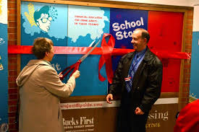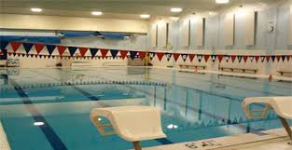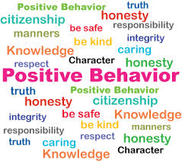

* Gym is scheduled every other day, for 6th-8th and once a week for 5th all year long.
* Students will alternate activities, including working in the gym, out on the fields, or in the pool
* Students are expected to be dressed for gym as this is the majority of their grade – but there is NO poquessing gear is required for gym clothes
* Students can come to school dressed for gym already or they can change in the locker room.
* For swimming – students can wear their bathing suit under their clothes before they have class and then change afterwards. If students need extra time for changing, please let us know
* Students can bring a gym lock for their gym locker – We suggest something simple that they can do quickly and remember easily so it does not get confused
* All students are given an individualized point sheet to help guide them through the day
* We ask that parents please sign the point sheets daily so you are aware of the behaviors we see during the school day. Students will bring them back to school the next day
* The students are working with an earned privileges based systems to reward them for expected behaviors and hard work in class

Technology

* Please charge device every night as devices are used every day
* Contact school with connectivity issues
* Student user names and passwords will be marked in their planners

# Lunch:

* Students can put money into their accounts during the lunch period – please put their lunch numbers on the check
* OR parents can add money to lunch accounts online

# Gym!!

## Daily Point Sheets:

