CPR and First AID
7TH GRADE
nOTEBOOK

Name:____________________________________
PEriod:___________________________________
Day: _____________________________________

DEFINE:

- First Aid:

- CPR:

IS IT AN EMERGENCY?
Your senses - hearing, sight and smell - may help you to recognize an emergency. Emergencies are often signaled by something unusual that catches your attention.
List some items that you might hear, see and smell that would indicate there might be an emergency.

1.______________________________________________

2.______________________________________________

3.______________________________________________

4.______________________________________________

5.______________________________________________

PA STANDARDS FOR HEALTH AND P.E.
10.3.6.B - Know and apply appropriate emergency responses
10.3.9 B – Strategies for emergency and long term management of injuries
10.3.12 B – Strategies for the management of injuries

Recognizing Emergencies
Your senses – hearing, sight and smell – may help you recognize an emergency. Emergencies are often signaled by something unusual that catches your attention. Examples include -
Unusual Sights |  | Unusual Appearance or Behaviors |  | Unusual Odors | Unusual Noises
Stopped vehicle on the roadside |  | Unconsciousness |  | Odors that are stronger than usual | Screaming, yelling, moaning or calling for help
Broken glass |  | Confused or unusual behavior |  | Unrecognizable odors | Breaking glass, crashing metal or screeching tires
Overturned pot in the kitchen |  | Trouble breathing |  | Inappropriate odors | Sudden, loud or unidentifiable sounds
Spilled medicine container |  | Clutching chest or throat |  |  | Unusual silence
Downed electrical wires |  | Slurred, confused or hesitant speech
Sparks, smoke or fire |  | Unexplainable confusion or drowsiness
 |  | Sweating for no apparent reason
 |  | Uncharacteristic skin color
 | Did You Know?
 | What Everyone Should Know About Good Samaritan Laws
 | Are Good Samaritan Laws there to protect you when you provide help in an emergency situation?  Yes, all 50 states have enacted Good Samaritan laws, which give legal protection to people who willingly provide emergency care to ill or injured persons without accepting anything in return.  Good Samaritan laws usually protect citizens who act the same way that a “reasonable and prudent person” would if that person were in the same situation. For example, a reasonable and prudent person would-  - Move a person only if the person’s life were in danger.  - Ask a conscious person for permission before giving care.  - Check the person for life-threatening conditions before giving further care.  - Call 9-1-1 or the local emergency number.  - Continue to give care until more highly trained personnel arrive. |  | Good Samaritan laws were developed to encourage people to help others in emergency situations. They require the “Good Samaritan” to use common sense and a reasonable level of skill, and to provide only the type of emergency first aid for which he or she is trained. They assume each person would do his or her best to save a life or prevent further injury.  Good Samaritan Protection in Lawsuits  Non-professionals who respond to emergencies, also called “lay responders,” are rarely sued for helping in an emergency. However, Good Samaritan laws protect the responder from financial responsibility. In cases in which a lay responder’s actions were deliberately negligent or reckless or when the responder abandoned the person after starting care, the courts have ruled Good Samaritan laws do not protect the responder.  If you are interested in finding out about your state’s Good Samaritan laws, contact a legal professional or check with your local library.

The 3 C’s:

Check
Before you can help an injured or ill person, you must check the scene to make sure it’s safe for you and any bystanders

- Is it safe?
- How many people are injured?
- What happened?
- Condition of injured person(s)
Call
Being prepared with information is crucial for an EMS dispatcher (911). The dispatcher will ask the following…
- Location:
a. Street Address
b. City or Town
c. Directions
d. Exits or Evacuation Routes or mile marker
- Telephone Number from which the call is being made:
- Caller’s Name
- What Happened
- How many people are injured?
6. Condition of the injured person(s)

Care
Once you have checked the scene and the person and a decision has been made about calling 911, you need to give care until EMS personnel arrive. To do so, you must follow these general guidelines:

Check the person to determine what care needs to be given!

Life Threatening Situations

Call ______if any of these are present!

Name__________________________________ Date________________ _____/25Pts

Being Prepared

Directions: Fill out all the information a 9-1-1 Dispatcher would need in case of an emergency. You are the caller and your emergency is that the attic/upper floor of your house is on fire.

Location:
- Street Address: (1pt) ______________________________________________________________
- City or Town: (1pt) ________________________________
- Directions: (From St. Mary’s Hospital 1201 Langhorne-Newtown Road., Langhorne, PA, 19047 to your home) (5pts) ________________________________________________________________________
________________________________________________________________________________________________________________________________________________________________________________________________________________________________________________________________________________________________________________________________________________________________________________________________________________________________________________________________________________________________________________________________________________________________________________________________________________________________________________________________________

Telephone Number from which the call is being made: (1pt) ___________________________________

Caller’s Name: (1pt) _____________________________________

What Happened: (1pt) __________________________________________________________________________________________________________________________________________________________________________________________________________________________________________

How many people are injured? (1pt) _________________________________________

Condition of the injured person(s) (1pt) ___________________________________________________________________________________________________________________________________________________________________________________________________________________________________________________

Directions: Discuss with your family what your exit route would be out of your house during an emergency situation. (10pts)

Draw a map of your Exits and Evacuation Routes out of your house from your bedroom (or place you sleep): (Draw the floor layout of your house. If you have multiple floors, draw all levels. Using 2 different colors, draw lines showing your first exit route out of the house and use a second color to draw an alternate route out in case your first route is blocked.)

After you have safely exited the house, where will you meet the rest of your family members: (3pts) __________________________________________________________________________________________________________________________________________________________________
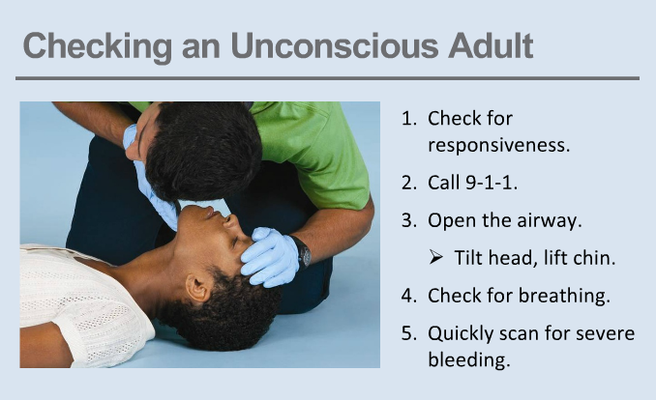

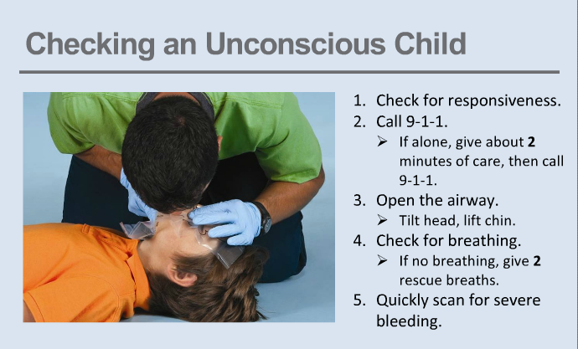

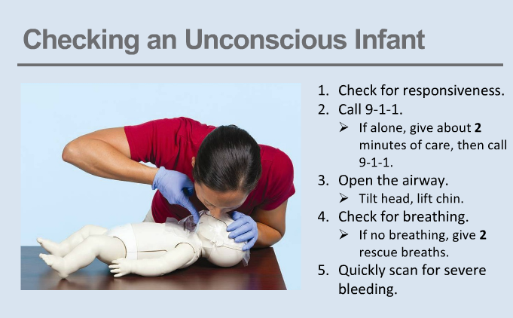

Review Questions

1. What are some common factors that keep people from responding to an emergency medical situation?

2. What is “normal breathing?”

3. You see a child sitting on the sidewalk near a bike with a cut on her leg. What do you need to keep in mind when giving her first aid care?

4. When should you move an injured or ill person?

Shock
- What is shock?
  - Shock is a ____________________ condition in which not enough blood is being delivered to all parts of the body and body systems, and organs ____________________. A person showing signals of shock need immediate ____________________. Shock is likely to develop after any serious injury or illness including ____________________, ____________________, ____________________ or other conditions. The goals of first aid are to get help quickly and give care to ____________________ shock while caring for the injury or illness.
- Signals of Shock
  - _______________________________________________
  - _______________________________________________
  - _______________________________________________
  - _______________________________________________
  - _______________________________________________
  - _______________________________________________
- Care for Shock
  - _____________________________________________________________________
  - _____________________________________________________________________
  - _____________________________________________________________________
  - _____________________________________________________________________
  - _____________________________________________________________________
  - _____________________________________________________________________
  - _____________________________________________________________________

Signals of a Heart Attack
The # l cause of heart attacks in the United States today is heart disease!

Persistent chest pain, discomfort or pressure lasting longer than 3-5 minutes or goes away and comes back. A person my deny having signals. Women may show more mild signs of a heart attack

Other signals:

Cardiac Chain of Survival

A.

B.

C.

D.

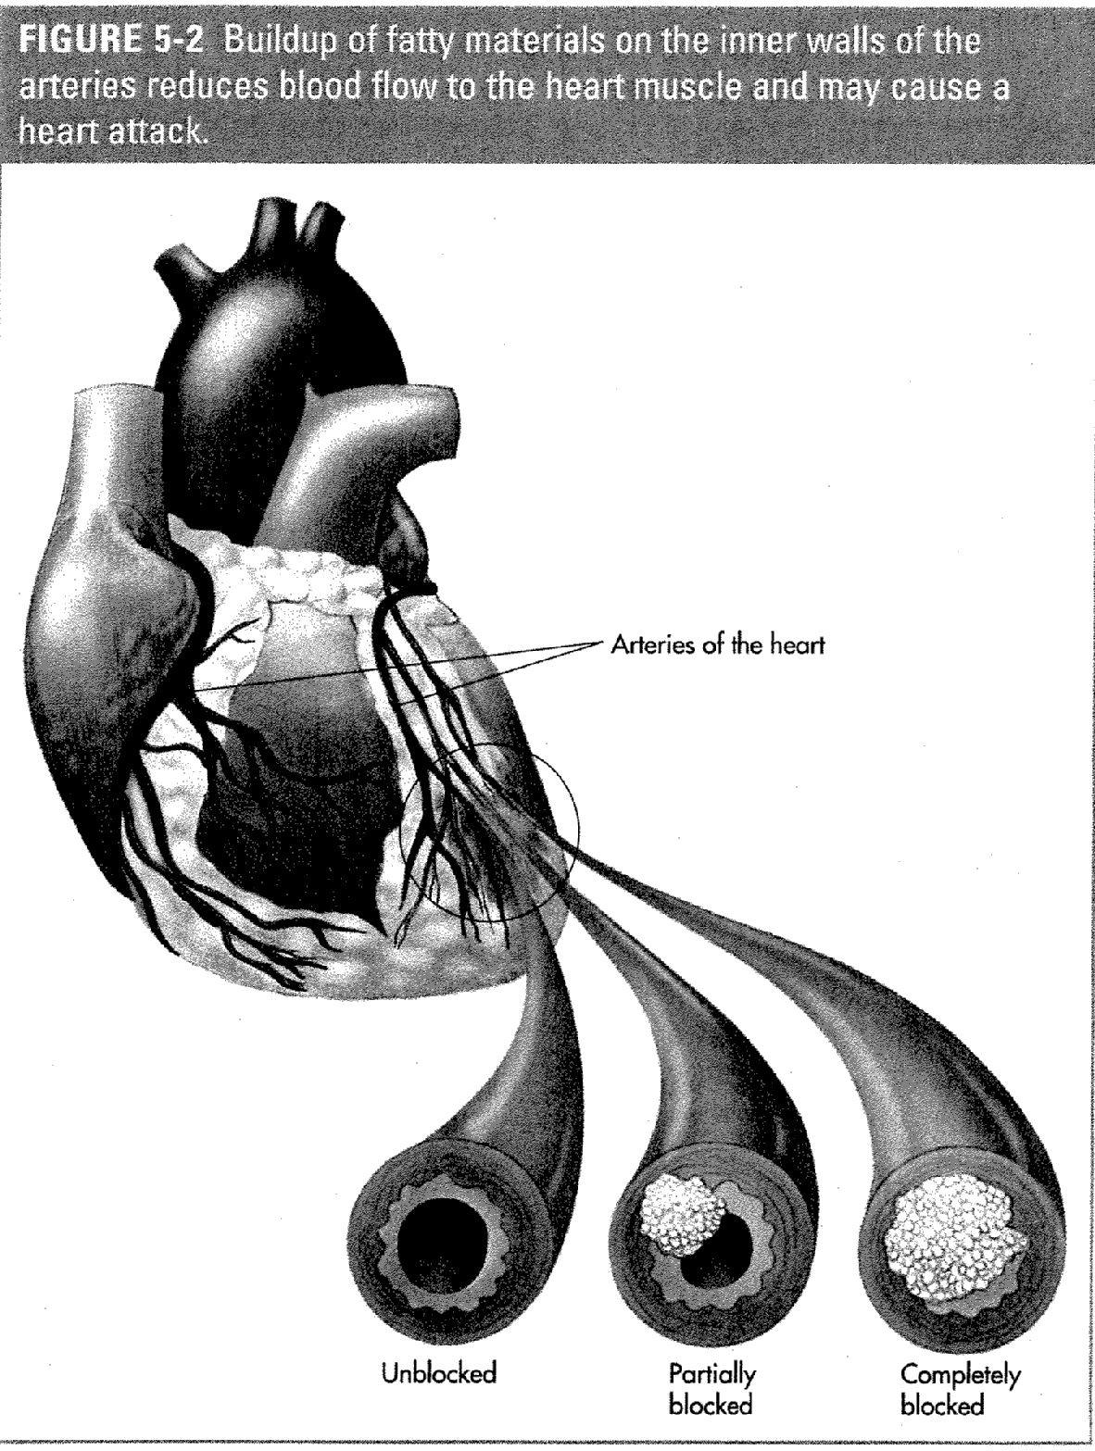
The 5 major causes of heart disease are

- ___________________________________

- ___________________________________

- ___________________________________

- ___________________________________

- ___________________________________

Other contributing factors:
Stress, heredity, lifestyle (drug use, etc.)

John’s Heart Attack

1. Name 3 habits that John has that are contributing to his heart attack.

a)

b)

c)

2. What is actually blocking his arteries?

3. What does shocking his heart really do?

4. What can you do to prevent a heart attack from happening to you?
C.P.R.

C______________________
P______________________
R______________________

When 9-1-1 has been called, immediately begin CPR. You are now the victim’s lung and heart.

Adult: 12 years old and older.
Child: 11 years old and younger.
Infant: Up to 1 year old
*Also depends on the size of the person.

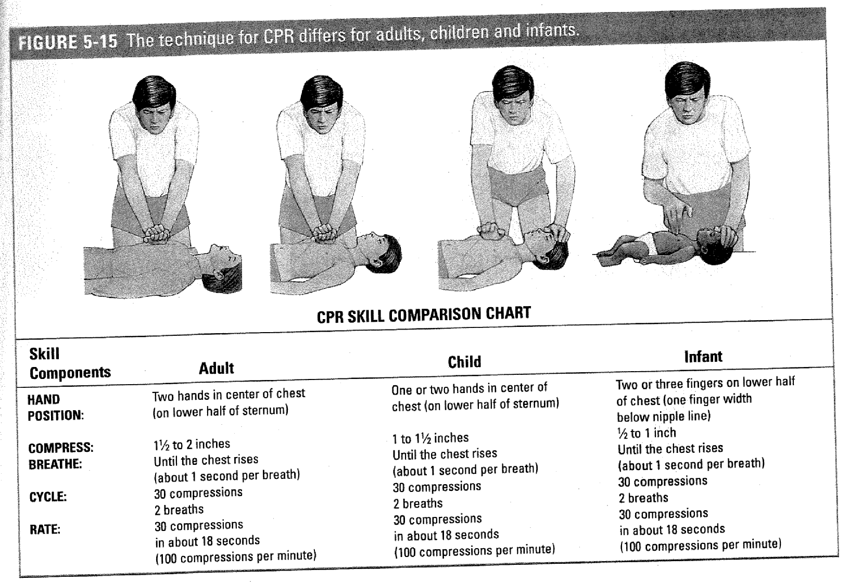

CPR Adult

Step 1: Give cycles of _______________ chest compressions and
_______ rescue breaths.

Step 2: Continue CPR until-
- Scene becomes ___________________________
- You find __________________________________
- _______________________________is ready to use.
- _________________________ arrives and takes over.

WHAT TO DO NEXT:
Use an ____________ as soon as it becomes available.

Hands only CPR (Compression Only)

1. If you are unable for any reason to perform full CPR, give continuous chest compressions after calling 9-1-1.

2. Continue giving chest compressions until another trained responder or EMS personnel take over or you notice an obvious sign of life.

AED Basics

A_____________ E_____________ D______________

Using an AED for Adult or Child

1. Turn on AED

2. Wipe bare chest dry

3. Attach pads
a. If pads might touch, use front/back placement

4. Plug in connector

5. Stand clear.

6. Deliver shock

1. Why is it important not to touch the person while the AED is analyzing?

2. Why is it important not to touch the person while the AED is defibrillating?

3. Why is it important to know CPR even if an AED is available?

Conscious Choking Adult/Child
(Cannot cough, speak or breathe)

- Give______ Back Blows

- Give _______ Abdominal thrusts
- Place fist above the naval
- Give quick, upward thrusts
- Continue back blows and abdominal thrust until:
  - _______________________________
  - _______________________________
  - _______________________________

Unconscious Choking Adult/ Child
Step 1: Tilt the ______________________ farther back. Try _____________
rescue breaths again.
Step 2: If ____________________ does __________________ rise-
Give _________ chest compressions.
Step 3: Look for an _________________________.

Step 4: ___________________________ if one is seen.

Step 5: Try _______________ rescue breaths.

WHAT TO DO NEXT:
If breaths do not go in –
Continue to steps 2 – 5.

If breaths go in –
Check for signs of .
Give care based on the conditions found

TIP: For a child, stand or kneel behind the child, depending on his or her size.

Sudden Illnesses

List Sudden Illnesses:

        - ______________________________
        - ______________________________
        - ______________________________
        - ______________________________
        - ______________________________
        - ______________________________

Caring for Sudden Illness:
When caring for sudden illness you should never second guess!
Call 9-1-1- if:
- A person is .
- A person is having trouble .
- Discomfort.
- Vomiting .
- Having a seizure lasting for more than minutes.
- Has a seizure and is .
- Has a severe headache or speech or other trouble speaking.
- Weakness or in his/her body.
- Injuries to the , or
__________________________.
- Possible broken .
- Appears to have been .

Signs of a Diabetic Illness (for which you should call 911 if present)
- The person is unconscious or about to lose consciousness.
- The person is conscious and unable to swallow.
- The person does not feel better within 5 minutes after taking sugar.
- You cannot find sugar immediately. Do not spend time looking for it.
Treatment of a Diabetic Illness
- If a diabetic person is conscious and can safely swallow food or fluids, give it to them, preferably in liquid form

Poison can enter the body through the following methods:
    - Ingestion
    - Inhalation
    - Absorption
    - Injection
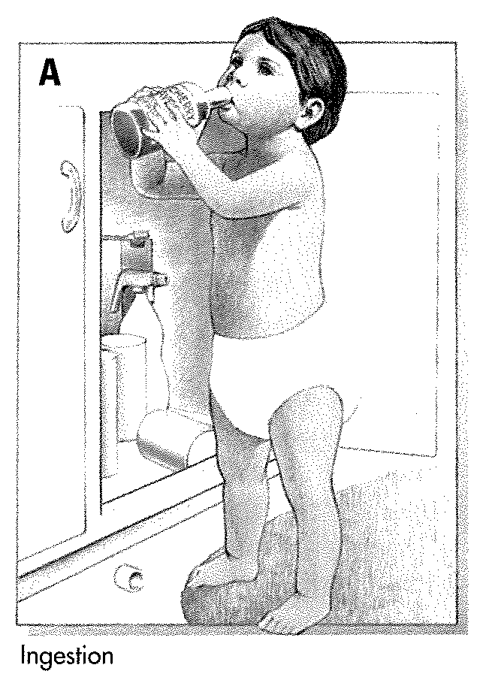
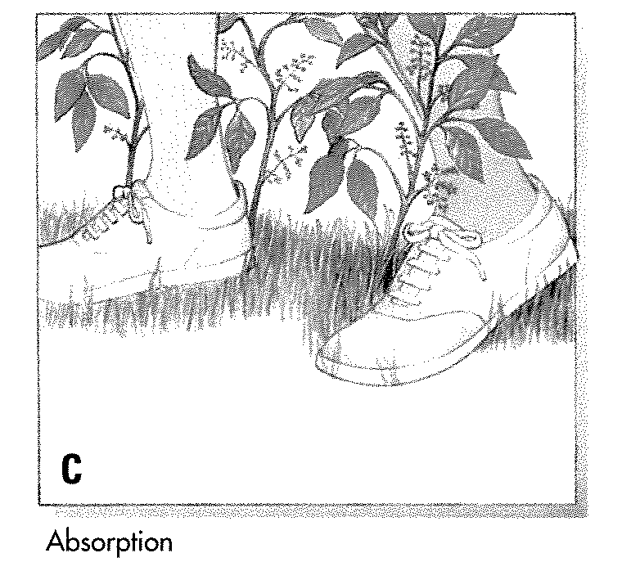
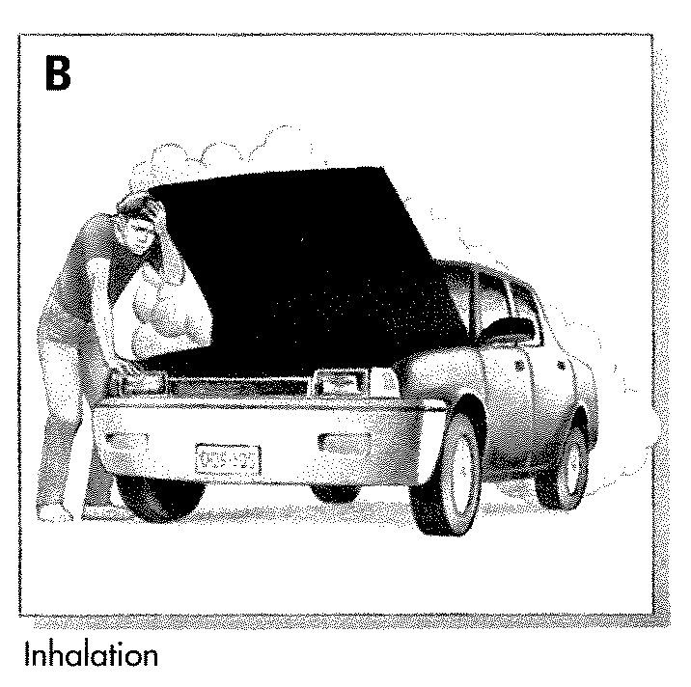
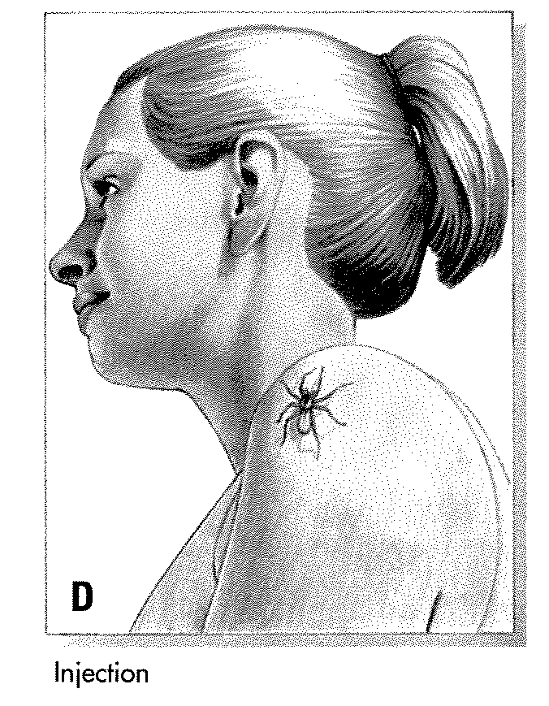
Match the word to the picture describing each word:
_______________
_______________
_______________
_______________

STROKE

What is a Stroke?

How could you tell if the person was having a stroke?

What does the acronym F.A.S.T. stand for?

F:
A:
S:
T:

Heat and Cold Related Emergencies

Heat Cramps: ________________________________________________________________
Heat Exhaustion: _______________________________________________________________
Heat Stroke: ___________________________________________________________________
Care:
- ___________________________________________________________________________
- ___________________________________________________________________________
- ___________________________________________________________________________
- ___________________________________________________________________________
- ___________________________________________________________________________
- ___________________________________________________________________________

Hypothermia: _______________________________________________________________
Care:
- ___________________________________________________________________________
- ___________________________________________________________________________
- ___________________________________________________________________________
- ___________________________________________________________________________
- ___________________________________________________________________________
- ___________________________________________________________________________
- ___________________________________________________________________________

Frostbite: ________________________________________________________________________
Care:
- ________________________________________________________________________
- ________________________________________________________________________
- ________________________________________________________________________
- ________________________________________________________________________
- ________________________________________________________________________
- ________________________________________________________________________
- ________________________________________________________________________
- ________________________________________________________________________
- ________________________________________________________________________

The air temperature DOES NOT have to be below freezing for someone to develop hypothermia!!!

Soft Tissue Injuries

Controlling external bleeding
(TIP: Wear disposable gloves and other personal protective equipment.)

Step 1: Check the___________, Check _______________.
Step 2: Obtain ________________________.
Step 3: ____________ wound with a sterile .
Step 4: Apply ______________ pressure until .

Step 5: Cover ________________ with .

STEP 6: If bleeding does not stop-
    - Apply additional .
    - Take steps to minimize .
    - Call if not already done.
NOTE: Wash hands with soap and water after giving care!

Types of Wounds

P– | Puncture:
S– | Scrape:
C– | Cut:
A– | Avulsion:.
B– | Bruise:

BURNS

Types of Burns:
1.___________________
2.___________________
3.___________________
4.___________________

CHARACTERISTICS OF BURNS:
First Degree:

Second Degree

Third Degree:

You should always call 9-1-1 if the burned person has:
1._______________________________________________________________________________
2._______________________________________________________________________________
3._______________________________________________________________________________
4._______________________________________________________________________________
5._______________________________________________________________________________
6._______________________________________________________________________________

REVIEW
Open/Closed Wounds

Members of our rescue squad have experienced both types of wounds (open and closed). For you to be an effective member of the rescue squad, you must be able to identify the different wounds and the care that needs to be provided for each.

- A climber slipped from the cliff face and smashed her back against the wall. Explain the care you would provide for her closed wound to ensure her safety?

- Fly-fishermen commonly acquire four (4) different types of open wounds. Identify these wounds and describe to the fisherman how to provide care for minor open wounds and major open wounds should such a case arise in the back-country.

- Infection can become a life or death situation under these circumstances. How can you tell if a wound is becoming infected and what care would you provide to treat this situation?

Bleeding

Our rescue squad gets a call from the south side of Bucks County about a possible dog bite. The park rangers on duty were able to stop the attack, but the camper is bleeding severely.

- What steps would you follow in an attempt to control his bleeding?

- What signals do you see that tell you he is in shock?

- What will you do to care for his shock condition?
Burns:

Members of our rescue squad have seen different types of burns throughout their experiences here in Bucks County. For you to better help people in need, you must be able to identify the different burns and the care that needs to be provided for each.

- Identify the four (4) different types of burns and how to care for each.

Injuries to Muscles, Bones and Joints:

Fracture- __________________________________________________
Dislocation- ________________________________________________
Sprain- ____________________________________________________
Strain- ____________________________________________________

Caring for muscles, bones and joints:

What does the acronym R.I.C.E stand for?

R:

I.

C.

E.

Concussions:
Signals of a concussion:
- ___________________________________
- ___________________________________
- ___________________________________
- ___________________________________
- ___________________________________
- ___________________________________
- ___________________________________

Care for a concussion:
- ___________________________________
- ___________________________________
- ___________________________________
- ___________________________________
Anaphylaxis Shock

What is Anaphylaxis?
________________________________________________________________________________

Identify the following pictures that are the common causes of an anaphylaxis reaction:




Asthma
A trigger is anything that sets off or starts an asthma attack. What are some asthma triggers?
- _____________________________________________________________________
- _____________________________________________________________________
- _____________________________________________________________________
- _____________________________________________________________________
- _____________________________________________________________________
- _____________________________________________________________________
- _____________________________________________________________________
- _____________________________________________________________________
- _____________________________________________________________________

Name 7 signals that an asthma attack is occurring.
- _____________________________________________________________________
- _____________________________________________________________________
- _____________________________________________________________________
- _____________________________________________________________________
- _____________________________________________________________________
- _____________________________________________________________________
- _____________________________________________________________________

REVIEW:
Asthma

An emergency call comes into the rescue squad from a backpacker whose partner cannot breathe normally. He knows his hiking partner suffers from a mild case of asthma and always carries his two (2) inhalers on adventures. This hiker needs the squad to explain the following in order to help his partner:

- What is happening during this asthma attack?

- What are some “triggers” that may have caused this attack?

- Which inhaler should the hiker administer to his partner (long-term medication or short-term medication)?

- What steps does he need to follow to administer the inhaler?

Anaphylaxis/Epipen

You are stationed at your school as part of their School Crisis Team. You receive a call from the cafeteria telling you that a student is having an allergic reaction known as anaphylactic shock. You know the student is allergic to peanuts, so you bring the student’s epinephrine auto-injector.

- What signals do you expect to see when you arrive at the scene?

- Explain the steps you would follow to assist with an epinephrine auto-injector.

