First aid and CPR
Let’s get started!
DEFINE:

- First Aid:

- CPR:

IS IT AN EMERGENCY?
Your senses - hearing, sight and smell - may help you to recognize an emergency. Emergencies are often signaled by something unusual that catches your attention.
List some items that you might hear, see and smell that would indicate there might be an emergency.

1.______________________________________________

2.______________________________________________

3.______________________________________________

4.______________________________________________

5.______________________________________________

PA STANDARDS FOR HEALTH AND P.E.
10.3.6.B - Know and apply appropriate emergency responses
10.3.9 B – Strategies for emergency and long term management of injuries
10.3.12 B – Strategies for the management of injuries

Recognizing Emergencies
Your senses – hearing, sight and smell – may help you recognize an emergency. Emergencies are often signaled by something unusual that catches your attention. Examples include -
Unusual Sights |  | Unusual Appearance or Behaviors |  | Unusual Odors | Unusual Noises
Stopped vehicle on the roadside |  | Unconsciousness |  | Odors that are stronger than usual | Screaming, yelling, moaning or calling for help
Broken glass |  | Confused or unusual behavior |  | Unrecognizable odors | Breaking glass, crashing metal or screeching tires
Overturned pot in the kitchen |  | Trouble breathing |  | Inappropriate odors | Sudden, loud or unidentifiable sounds
Spilled medicine container |  | Clutching chest or throat |  |  | Unusual silence
Downed electrical wires |  | Slurred, confused or hesitant speech
Sparks, smoke or fire |  | Unexplainable confusion or drowsiness
 |  | Sweating for no apparent reason
 |  | Uncharacteristic skin color
 | Did You Know?
 | What Everyone Should Know About Good Samaritan Laws
 | Are there to protect you when you provide help in an emergency situation?  Yes, all 50 states have enacted Good Samaritan laws, which give legal protection to people who willingly provide emergency care to ill or injured persons without accepting anything in return.  Good Samaritan laws usually protect citizens who act the same way that a “reasonable and prudent person” would if that person were in the same situation. For example, a reasonable and prudent person would-  - Move a person only if the person’s life were in danger.  - Ask a conscious person for permission before giving care.  - Check the person for life-threatening conditions before giving further care.  - Call 9-1-1 or the local emergency number.  - Continue to give care until more highly trained personnel arrive. |  | Good Samaritan laws were developed to encourage people to help others in emergency situations. They require the “Good Samaritan” to use common sense and a reasonable level of skill, and to provide only the type of emergency first aid for which he or she is trained. They assume each person would do his or her best to save a life or prevent further injury.  Good Samaritan Protection in Lawsuits  Non-professionals who respond to emergencies, also called “lay responders,” are rarely sued for helping in an emergency. However, Good Samaritan laws protect the responder from financial responsibility. In cases in which a lay responder’s actions were deliberately negligent or reckless or when the responder abandoned the person after starting care, the courts have ruled Good Samaritan laws do not protect the responder.  If you are interested in finding out about your state’s Good Samaritan laws, contact a legal professional or check with your local library.
Check
Before you can help an injured or ill person, you must check the scene to make sure it’s safe for you and any bystanders

- Is it safe?
- How many people are injured?
- What happened?
- Condition of injured person(s)
Call
Being prepared with information is crucial for an EMS dispatcher (911). The dispatcher will ask the following…
- Location:
a. Street Address
b. City or Town
c. Directions
d. Exits or Evacuation Routes or mile marker
- Telephone Number from which the call is being made:
- Caller’s Name
- What Happened
- How many people are injured?
6. Condition of the injured person(s)

Care
Once you have checked the scene and the person and a decision has been made about calling 911, you need to give care until EMS personnel arrive. To do so, you must follow these general guidelines:

Check the person to determine what care needs to be given!

Review: List 3 items that would signal an emergency.

- ______________________________________________________
- ______________________________________________________
- ______________________________________________________

Journal Question of the Day:

Why might you not help in an emergency situation? List 2 reasons.

________________________________________________________________________________________________________________________________________________________________________________________________________________________________________________________________________________________________________________________________________________________________________________________________________________________________________________________________

Life Threatening Situations
(Pictionary)

Checking an Unconscious Adult:

1. Check for responsiveness

2. Call 9-1-1

3. Open the airway.
a. Tilt the head
b. Lift the chin

4. Check for breathing

5. Quickly scan for severe bleeding

Shock
- What is shock?
  - Shock is a ____________________ condition in which not enough blood is being delivered to all parts of the body and body systems, and organs ____________________. A person showing signals of shock need immediate ____________________. Shock is likely to develop after any serious injury or illness including ____________________, ____________________, ____________________ or other conditions. The goals of first aid are to get help quickly and give care to ____________________ shock while caring for the injury or illness.
- Signals of Shock
  - _______________________________________________
  - _______________________________________________
  - _______________________________________________
  - _______________________________________________
  - _______________________________________________
  - _______________________________________________
- Care for Shock
  - _______________________________________________________________________
  - _______________________________________________________________________
  - _______________________________________________________________________
  - _______________________________________________________________________
  - _______________________________________________________________________
  - _______________________________________________________________________
  - _______________________________________________________________________

Review Questions

1. What are some common factors that keep people from responding to an emergency medical situation?

2. What is “normal breathing?”

3. You see a child sitting on the sidewalk near a bike with a cut on her leg. What do you need to keep in mind when giving her first aid care?

4. When should you move an injured or ill person?

Signals of a Heart Attack

Persistent chest pain, discomfort or pressure lasting longer than 3-5 minutes or goes away and comes back. A person my deny having signals. Women may show more mild signs of a heart attack

Other signals:

Cardiac Chain of Survival

A.

B.

C.

D.

Heart Attacks

The # l cause of heart attacks in the United States today is heart disease!

The 5 major causes of heart disease are

- ___________________________________

- ___________________________________

- ___________________________________

- ___________________________________

- ___________________________________

Other contributing factors:

Stress, heredity, lifestyle (drug use, etc.)
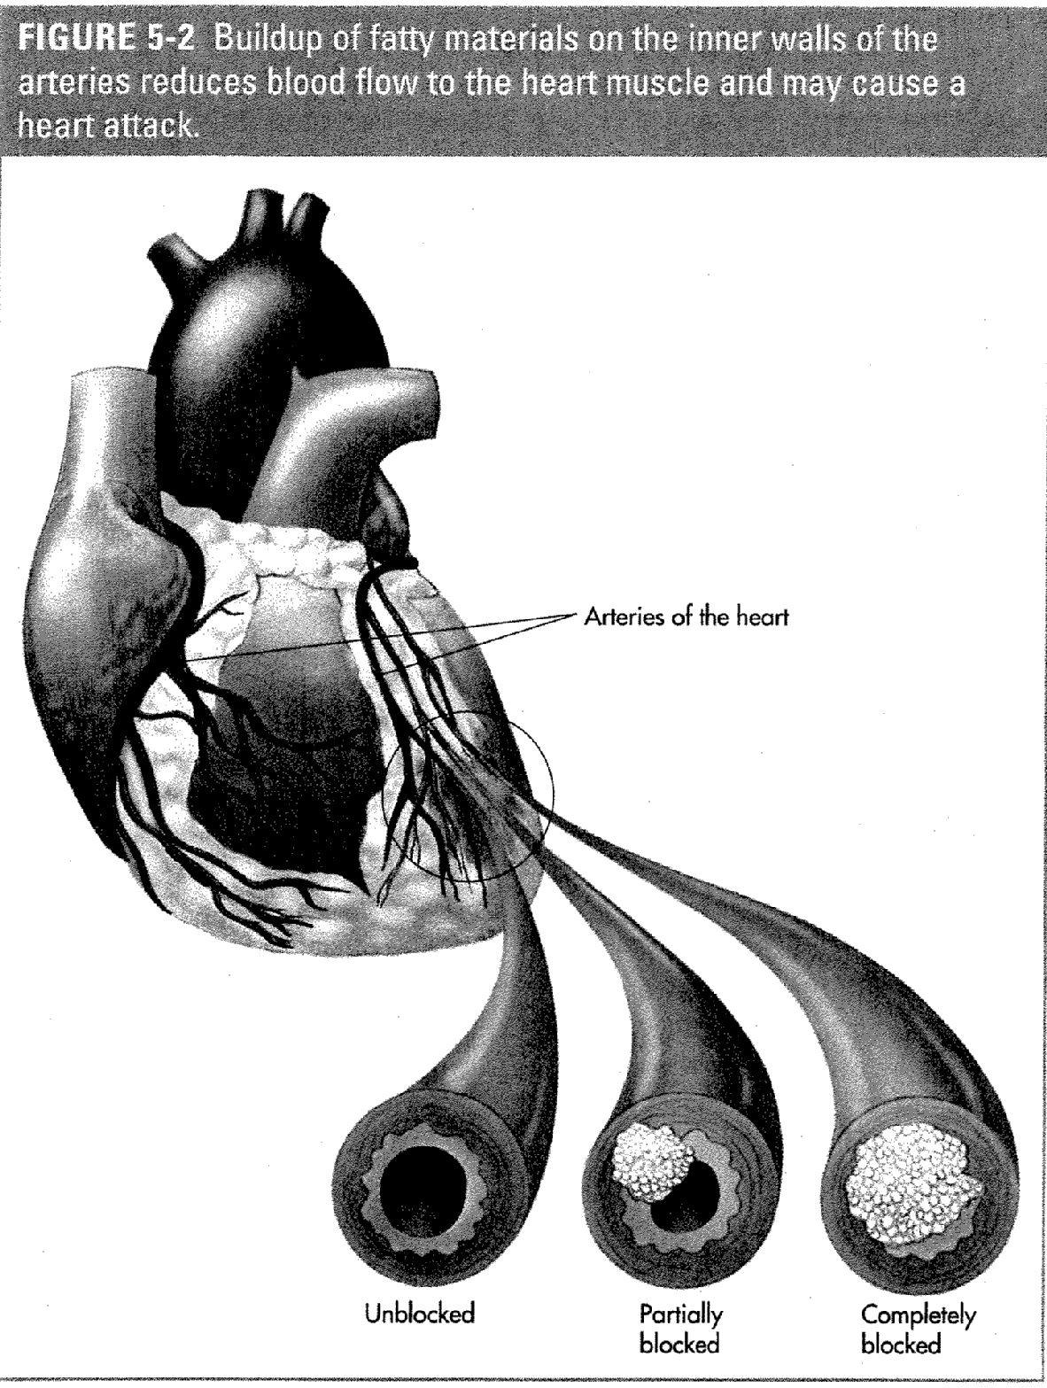

John’s Heart Attack

1. Name 3 habits that John has that are contributing to his heart attack.

a)

b)

c)

2. What is actually blocking his arteries?

3. What does shocking his heart really do?

4. What can you do to prevent a heart attack from happening to you?

Hands only CPR

1. If you are unable for any reason to perform full CPR, give continuous chest compressions after calling 9-1-1.

2. Continue giving chest compressions until another trained responder or EMS personnel take over or you notice an obvious sign of life.

AED Basics

A_____________ E_____________ D______________

Using an AED for Adult or Child

1. Turn on AED

2. Wipe bare chest dry

3. Attach pads
a. If pads might touch, use front/back placement

4. Plug in connector

5. Stand clear.

6. Deliver shock

1. Why is it important not to touch the person while the AED is analyzing?

2. Why is it important not to touch the person while the AED is defibrillating?

3. Why is it important to know CPR even if an AED is available?

Conscious Choking Adult/Child

- Give 5 Back Blows

- Give 5 Abdominal thrusts

- Place fist above the naval
- Give quick, upward thrusts

Sudden Illnesses

What is a Stroke?

How could you tell if the person was having a stroke?

F.
A.
S.
T.

Congratulations for being accepted as a new member of the Idlewood County Rescue Squad!

Throughout history the following situations have commonly occurred and posed threats to the lives of outdoor enthusiasts and other visitors within Idlewood County. Injuries are the leading cause of death for all ages.

Members of the Idlewood County Rescue Squad have the following responsibilities:

- Minimize these life-threatening situations from occurring by reviewing wilderness first aid and safety skills with outdoor groups.
- Search and Rescue Missions

This session of the course will help members review and develop their first aid and safety skills. This will help them provide better instruction to their expedition groups and remedy life-threatening situations during search and rescue missions.
- Asthma
- Wounds
- Burns
- Anaphylaxis
- Bleeding and Shock
- Sudden Illnesses
- Poisoning

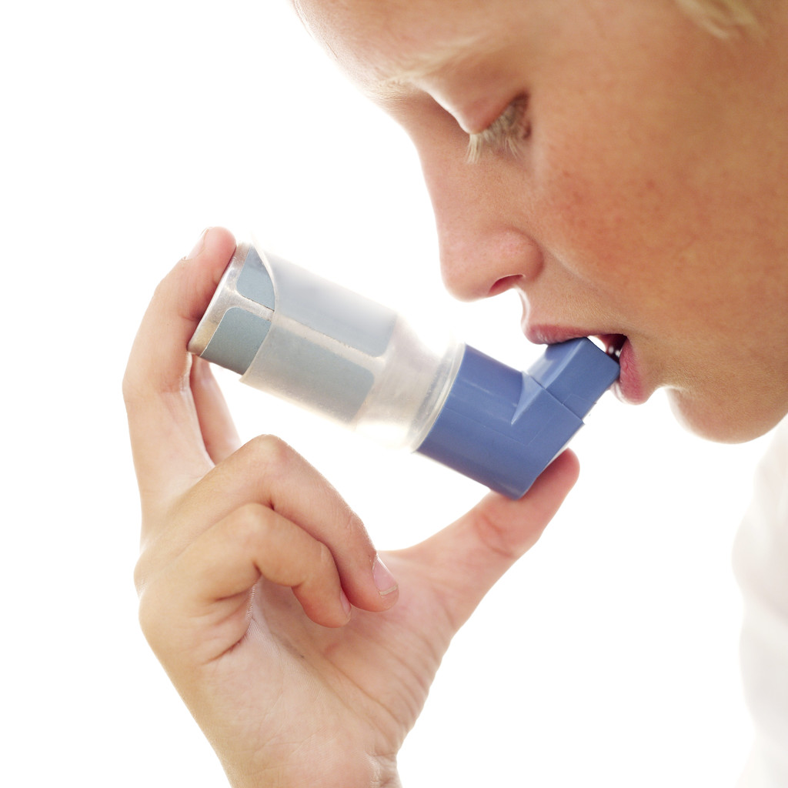

- An emergency call comes into the rescue squad from a backpacker whose partner can not breathe normally. He knows his hiking partner suffers from a mild case of asthma and always carries his two (2) inhalers on adventures. This hiker needs the squad to explain the following in order to help his partner:

- What is happening during this asthma attack?

- What are some “triggers” that may have caused this attack?

- Which inhaler should the hiker administer to his partner (long-term medication or short-term medication)?

- What steps does he need to follow to administer the inhaler?

- Members of our rescue squad have experienced both types of wounds (open and closed). For you to be an effective member of the rescue squad, you must be able to identify the different wounds and the care that needs to be provided for each.

- A climber slipped from the cliff face and smashed her back against the wall. What type of closed wound was it and explain the care you would provide for her closed wound to ensure her safety?

- Bike Riders commonly fall and scrape knees elbows and arms. What type of closed wound is this and how would you care for the injury?

- Infection can become a life or death situation under these circumstances. How can you tell if a wound is becoming infected and what care would you provide to treat this situation?



- Members of our rescue squad have seen different types of burns throughout their experiences here in Idlewood County. For you to better help people in need, you must be able to identify the different burns and the care that needs to be provided for each.

- Identify the four (4) different types of burns and how to care for each.

- You are stationed at Neshaminy High School as part of their School Crisis Team. You receive a call from the cafeteria telling you that a student is having an allergic reaction known as anaphylactic shock. You know the student is allergic to peanuts, so you bring the student’s epinephrine auto-injector.

- What signals do you expect to see when you arrive at the scene?

- Explain the steps you would follow to assist with an epinephrine auto-injector.

- Our rescue squad gets a call from the south side of Idlewood County about a possible mountain lion bite. The park rangers on duty were able to stop the attack, but the camper is bleeding severely.

- What steps would you follow in an attempt to control his bleeding?

- What signals do you see that tell you he is in shock?

- What will you do to care for his shock condition?

- Some of the emergency calls that the Idlewood County Rescue Squad receives are due to sudden illnesses (fainting, diabetes, seizures, and stroke).

- Explain the care that you would provide for each of the following situations:

Fainting:

Diabetes:

Seizures:

Stroke:



- As we know if a person is expected to have some type of substance overdose we should call the Poison Control Center and 911. People can be victims of various forms of poison when spending time in Idlewood County’s Wilderness Area.

- According to our manual, some of the possible bites/stings that could pose problems for park users are insect, spider, and snake bites. What care would you provide for each?

Insect:

Spider:

Snake:

- One of our rescue squad members was bitten by a small deer tick. How should he remove the tick?

It is now 4 weeks later and he thinks that he may be suffering from Lyme’s Disease. He doesn’t know the signs and asks you to identify them for him.

