8th Grade Health
Sexuality: Student Edition

Name: ______________________________
ODD / EVEN

Record of Progress
Date of Assign | Date of Collect | Title of Assignment | Point Worth | Current Total | My Score | My Total | My Grade
Lesson 1 - Starting Out
Lesson Outline 1.0

Health Standards:
- Students will comprehend concepts related to health promotion and disease prevention.
- Students will demonstrate the ability to practice health-enhancing behaviors and reduce health risks.
- Students will demonstrate the ability to use interpersonal communication skills to enhance health.

Objectives:
- To introduce students to the course and establish a friendly atmosphere, basic ground rules, identify and affirm positive personal qualities, and link self-esteem with the topic of human sexuality.

Vocabulary:

Self-Esteem: ___________________________________________________ ____________________________________________________________________________________________________________________________

Self-Respect: ___________________________________________________ ____________________________________________________________________________________________________________________________

Sexuality: _____________________________________________________ ____________________________________________________________________________________________________________________________
COURSE OVERVIEW
Home Activity 1.2

Directions:. Complete part II with your parent and bring with you back to the next class.
Part 1

Schedule Topic
Date _________________________ Starting Out (Sense of Self)
_________________________ What’s Really Important (Values)
_________________________ Changes (Puberty)
_________________________ Pregnancy and Birth
_________________________ More Changes (Feelings of Attraction)
_________________________ Equal Though Different (Sexism and Stereotypes)
_________________________ Making Choices
_________________________ Going Out? (Dating)
_________________________ Saying No!
_________________________ Planning for the Future
_________________________ Teenage Pregnancy: The Realities
_________________________ Teenage Pregnancy: The Choices
_________________________ Taking Chances (Sexually Transmitted Diseases)
_________________________ The Power of Touch (Sexual Abuse)
_________________________ Moving On!
Part II
[Bring This Section to Your Next Class]

Parent Response:

Student Response:

- The most important topic in this list above is:
______________________________________________________
- The most difficult topic to talk about is:
______________________________________________________

- The most important topic in this list is:
______________________________________________________
- The most difficult topic to talk about is:
___________________________________________________

Parent Signature: _____________________________________
In-Class Activity 1.1

Seeing the Positive
Circle at least 5 qualities that best describe YOU!

Kind
Honest
Considerate
Caring
Helpful
Loving
Funny
Patient
Outgoing
Ambitious
Proud
Friendly
Loyal
Patriotic
Grateful
Thoughtful
Hard-working
Healthy
A Leader
Understanding
Smart
Strong
Attractive
Athletic
Creative
Sensitive
Musical
Good Listener

Not Listed but True About You:
__________________ _________________ __________________

Lesson Outline 2.0
Lesson 2 - What's Really Important

Health Standards:
- Students will comprehend concepts related to health promotion and disease prevention.
- Students will analyze the influence of culture, media, technology, and other factors on health.
- Students will demonstrate the ability to use interpersonal communication skills to enhance health.

Objectives:
- To increase students’ understanding of the concept of values and the role of values in decision-making
- To increase students’ familiarity with the basic values promoted by this curriculum.

Class Notes:

\
Vocabulary:

Equality: ______________________________________________________ ____________________________________________________________________________________________________________________________

Honesty: ______________________________________________________ ____________________________________________________________________________________________________________________________

Promise Keeping: _______________________________________________ ____________________________________________________________________________________________________________________________

Respect: _______________________________________________________ ____________________________________________________________________________________________________________________________

Responsibility: _________________________________________________ ____________________________________________________________________________________________________________________________

Self-Control: ___________________________________________________ ____________________________________________________________________________________________________________________________

Social Justice: __________________________________________________ ____________________________________________________________________________________________________________________________

Who’s Teaching Me VALUES?
Choose from the following values to answer these questions:
Equality
Promise-Keeping
In-class Activity 2.2
Honesty
Respect
Self-Control
Social Justice
Responsibility

Which is emphasized the most by the principal of your school?

Which is emphasized the most by your favorite teacher?

Which is emphasized by the teacher who makes you work the hardest?

Which seems most important to your mother?

Which seems most important to your father?

Which seems most important to your friends?

Which are you BEST at doing?

Which do you need to work on the most?

When younger kids look at me, what value am I teaching them?

Which Value?

Using the 7 Values we discussed, match a value to the situation.
In-class Activity 2.3

A friend tells you that they have a crush on someone and tells you not to tell anyone. You decide to tell one other person and soon the whole class knows.
Value not Used: _____________________________________
Consequence for your action:

You have a substitute teacher in your class and you decide that this would be a good day to shoot spitballs at your classmates.
Value not Used: _____________________________________
Consequence for your action:

A classmate invites you to come over to hang out one day but you know that they live in a tiny house that’s much smaller than yours and you don’t want your friends to know that you were there.
Value not Used: _____________________________________
Consequence for your action:

You’re supposed to study because you have a test the next day but you play video games instead.
Value not Used: _____________________________________
Consequence for your action:

You are getting a bad grade in one of your classes but when your parents asked how you were doing you told them that you were doing well.
Value not Used: _____________________________________
Consequence for your action:

During lunch, you keep dropping stuff on the floor and when the lunch aide asks you to pick it up you tell them to do it because that’s their job.
Value not Used: ___________________________________________
Consequence for your action:

During PE, you pass the ball to the boys on your team because you know that the boys are better at sports than the girls.
Value not Used: ___________________________________________
Consequence for your action:

What I Think
Home Activity 2.1 A
[Student Opinion]
Directions: Please fill in the blanks with your own ideas. Then discuss with your parents what both of you think.

- What’s OK and what’s not OK about teenagers seeing Rated R or NC 17 movies?
What I think: ____________________________________________________________ _______________________________________________________________________
- What’s OK and what’s not about teenagers reading pornographic magazines and visiting pornographic websites?
What I think: ____________________________________________________________ _______________________________________________________________________
- What’s OK and what’s not about teenagers wearing sexy clothes?
What I think: ____________________________________________________________ _______________________________________________________________________
- What’s OK and what’s not about language – swearing and slang?
What I think: ____________________________________________________________ _______________________________________________________________________
- What’s OK and what’s not about sexual activity for teenagers?
What I think: ____________________________________________________________ _______________________________________________________________________
What I Think
[Parent Opinion]
Home Activity 2.1 B
Directions: Please fill in the blanks with your opinions about the following topics and return this to your child to bring back to class. Your son/daughter is completing the same assignment. Please feel free to discuss this at home.

- What’s OK and what’s not OK about teenagers seeing R or NC-17 movies?
What I think: ____________________________________________________________ _______________________________________________________________________
- What’s OK and what’s not about teenagers reading pornographic magazines and visiting pornographic websites?
What I think: ____________________________________________________________ _______________________________________________________________________
- What’s OK and what’s not about teenagers wearing sexy clothes?
What I think: ____________________________________________________________ _______________________________________________________________________
- What’s OK and what’s not about language – swearing and slang?
What I think: ____________________________________________________________ _______________________________________________________________________
- What’s OK and what’s not about sexual activity for teenagers?
What I think: ____________________________________________________________ _______________________________________________________________________
Parent Signature: ___________________________________________________________

Extra Credit Activity 2.4
Values are qualities in life that are very important to us. The choices we make most often show what value we hold. The things we value in life are part of who we are.

Directions: On a poster board, post pictures of things that you value. These things may come from magazines, photographs, and/or your own personal drawings. You will need at least 10 items. This is at the very least! Your poster should be filled! You will also need to post your name… LARGE so it can be seen! Use colors, pictures that represent who you are as a person. Show what matters to you, and what you think is important!

Remember: Values are something that money CANNOT buy!!!

Possible Examples:
- Photograph of your best friend
- Drawing of your dog
- Magazine cutout of your favorite sports team/person
- Sayings or phrases such as MEMORIES

If you have any questions about something you would like to put on your poster or are unsure if it is ok…ASK!!!

Due: _________________________________________________________________________
Lesson 3 - Changes
Lesson Outline 3.0

Health Standards:
- Students will comprehend concepts related to health promotion and disease prevention.
- Students will demonstrate the ability to access valid health information and health-promoting products and services.

Objectives:
- To increase students’ understanding of the concept of values and the role of values in decision-making
- To increase students’ familiarity with the basic values promoted by this curriculum

Vocabulary:

Conception: ____________________________________________________ ____________________________________________________________________________________________________________________________
Ejaculation: ____________________________________________________ ____________________________________________________________________________________________________________________________
Ovulation: _____________________________________________________ ____________________________________________________________________________________________________________________________
Menstruation: __________________________________________________ ____________________________________________________________________________________________________________________________
Puberty: _______________________________________________________ ____________________________________________________________________________________________________________________________

Body Changes
In-Class Activity 3.1

Adult Female Body: broader hips; rounding of body contours.
Adult Male Body: broader shoulders and chest; greater muscle development.

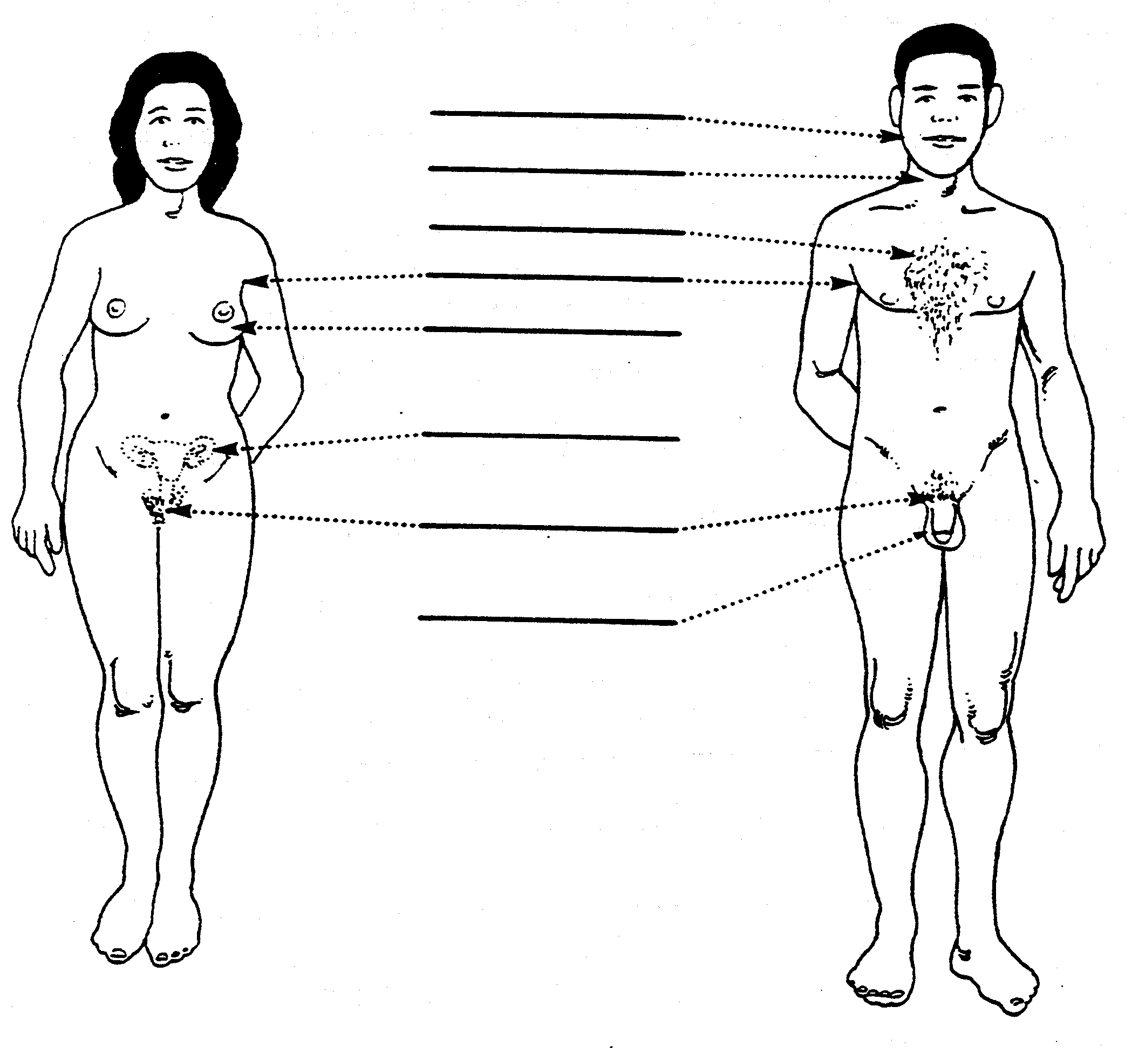
Female Hormones:

____________________________________
Male Hormone:

____________________________________

Male Reproductive System
In-Class Activity 3.3
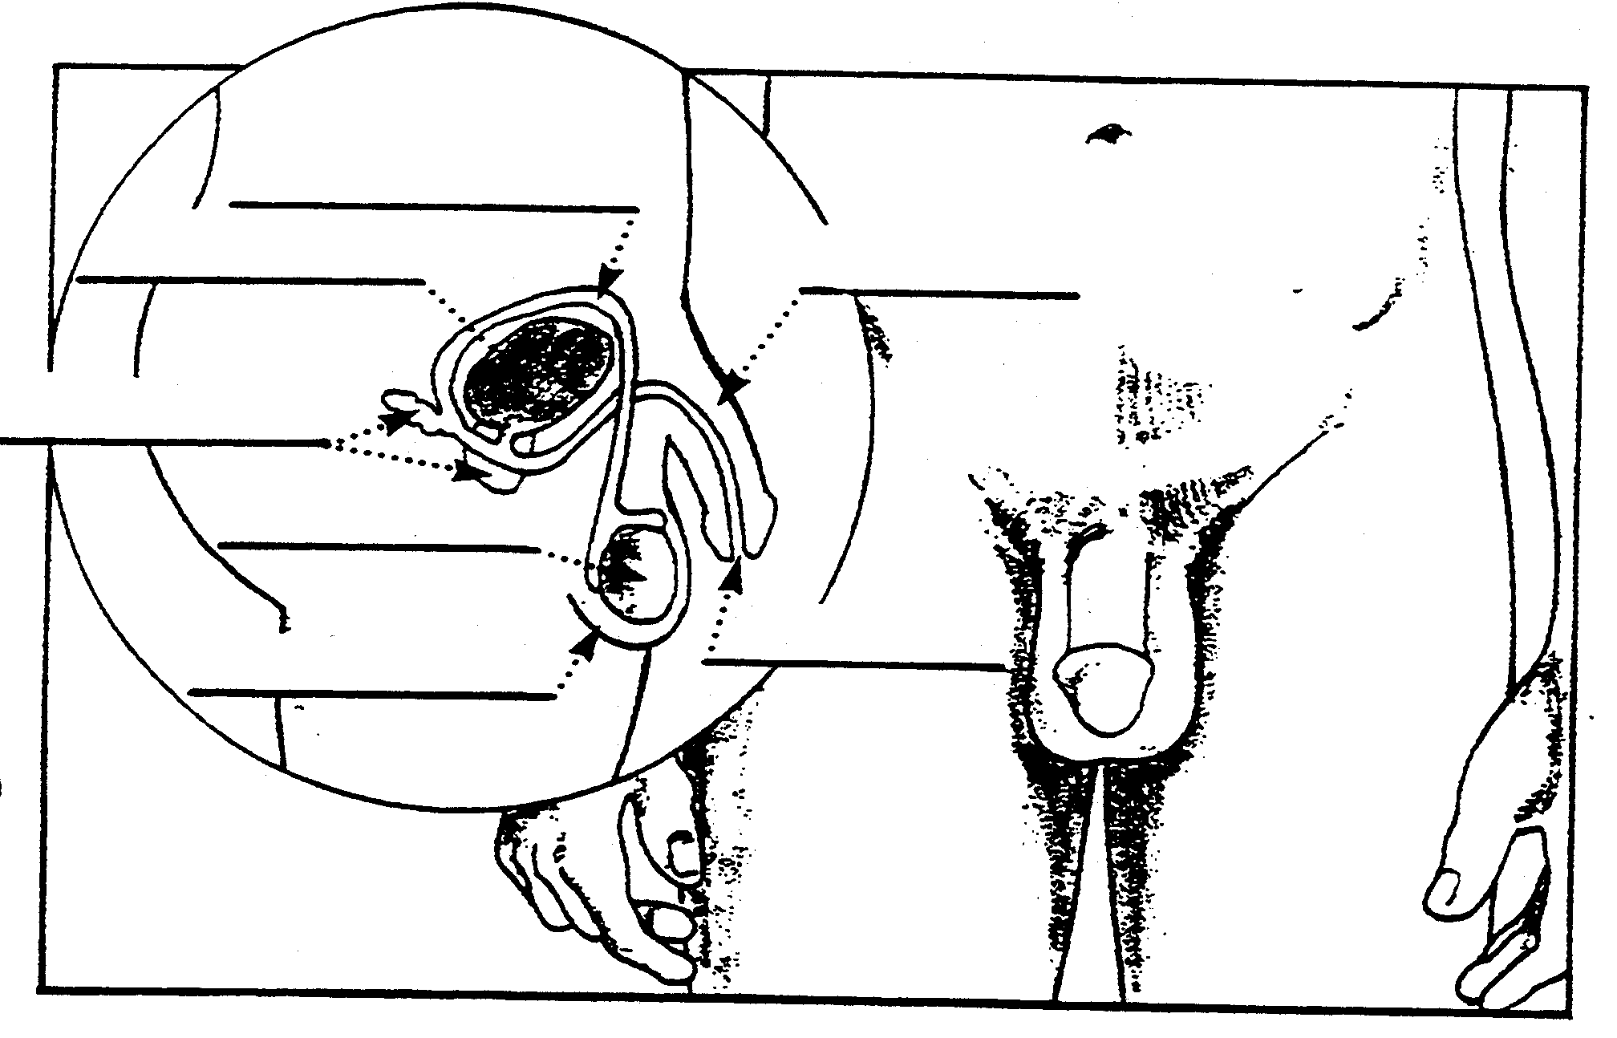
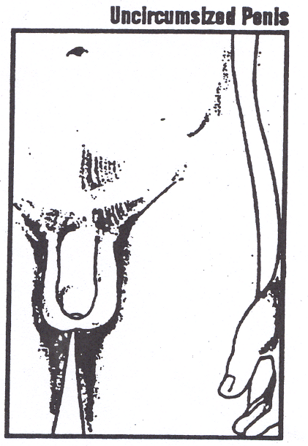

Notes: ____________________________________________________________________________________________________________________________________________________________________________________________________________________________________________________________________________________________________________________________________________________________________________________________________________________________________________
In-class Activity 3.4

Structure | Function
Vas Deferens / Sperm Duct | Carries sperm upward from the testes to the Seminal Vesicle.
Prostate Gland | Secretes fluid that initiates the movement of sperm. May produce pre-ejaculation.
Penis | Male reproductive organ for urination and the release of semen.
Scrotum | Encloses the two testes. Maintains the testes at a temperature suitable for sperm production.
Testes | Secretes testosterone. Produces sperm.
Seminal Vesicle | Secretes fluid to nourish the sperm. Assists in sperm movement.
Bladder | The organ where urine is stored.
Urethra | Serves as a passageway for urine and sperm/semen.

Female Reproductive System (External)
In-Class Activity 3.2 a
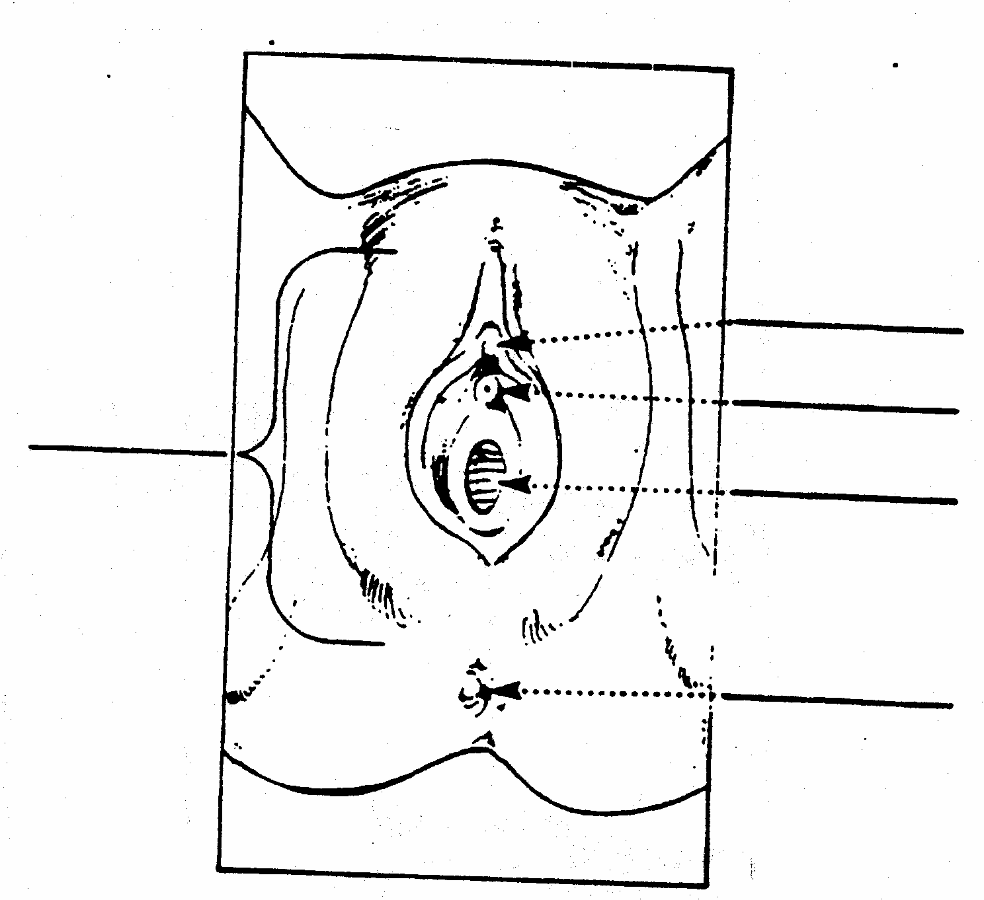

Notes: ______________________________________________ ________________________________________________________________________________________________________________________________________________________________________________________________________________________________________________________________________________________________________________________________________________________________________________________________________________________________________________________________________________________________________________________________________________________________________________________________________________________________________________

Female Reproductive System (Internal)
In-Class Activity 3.2 b
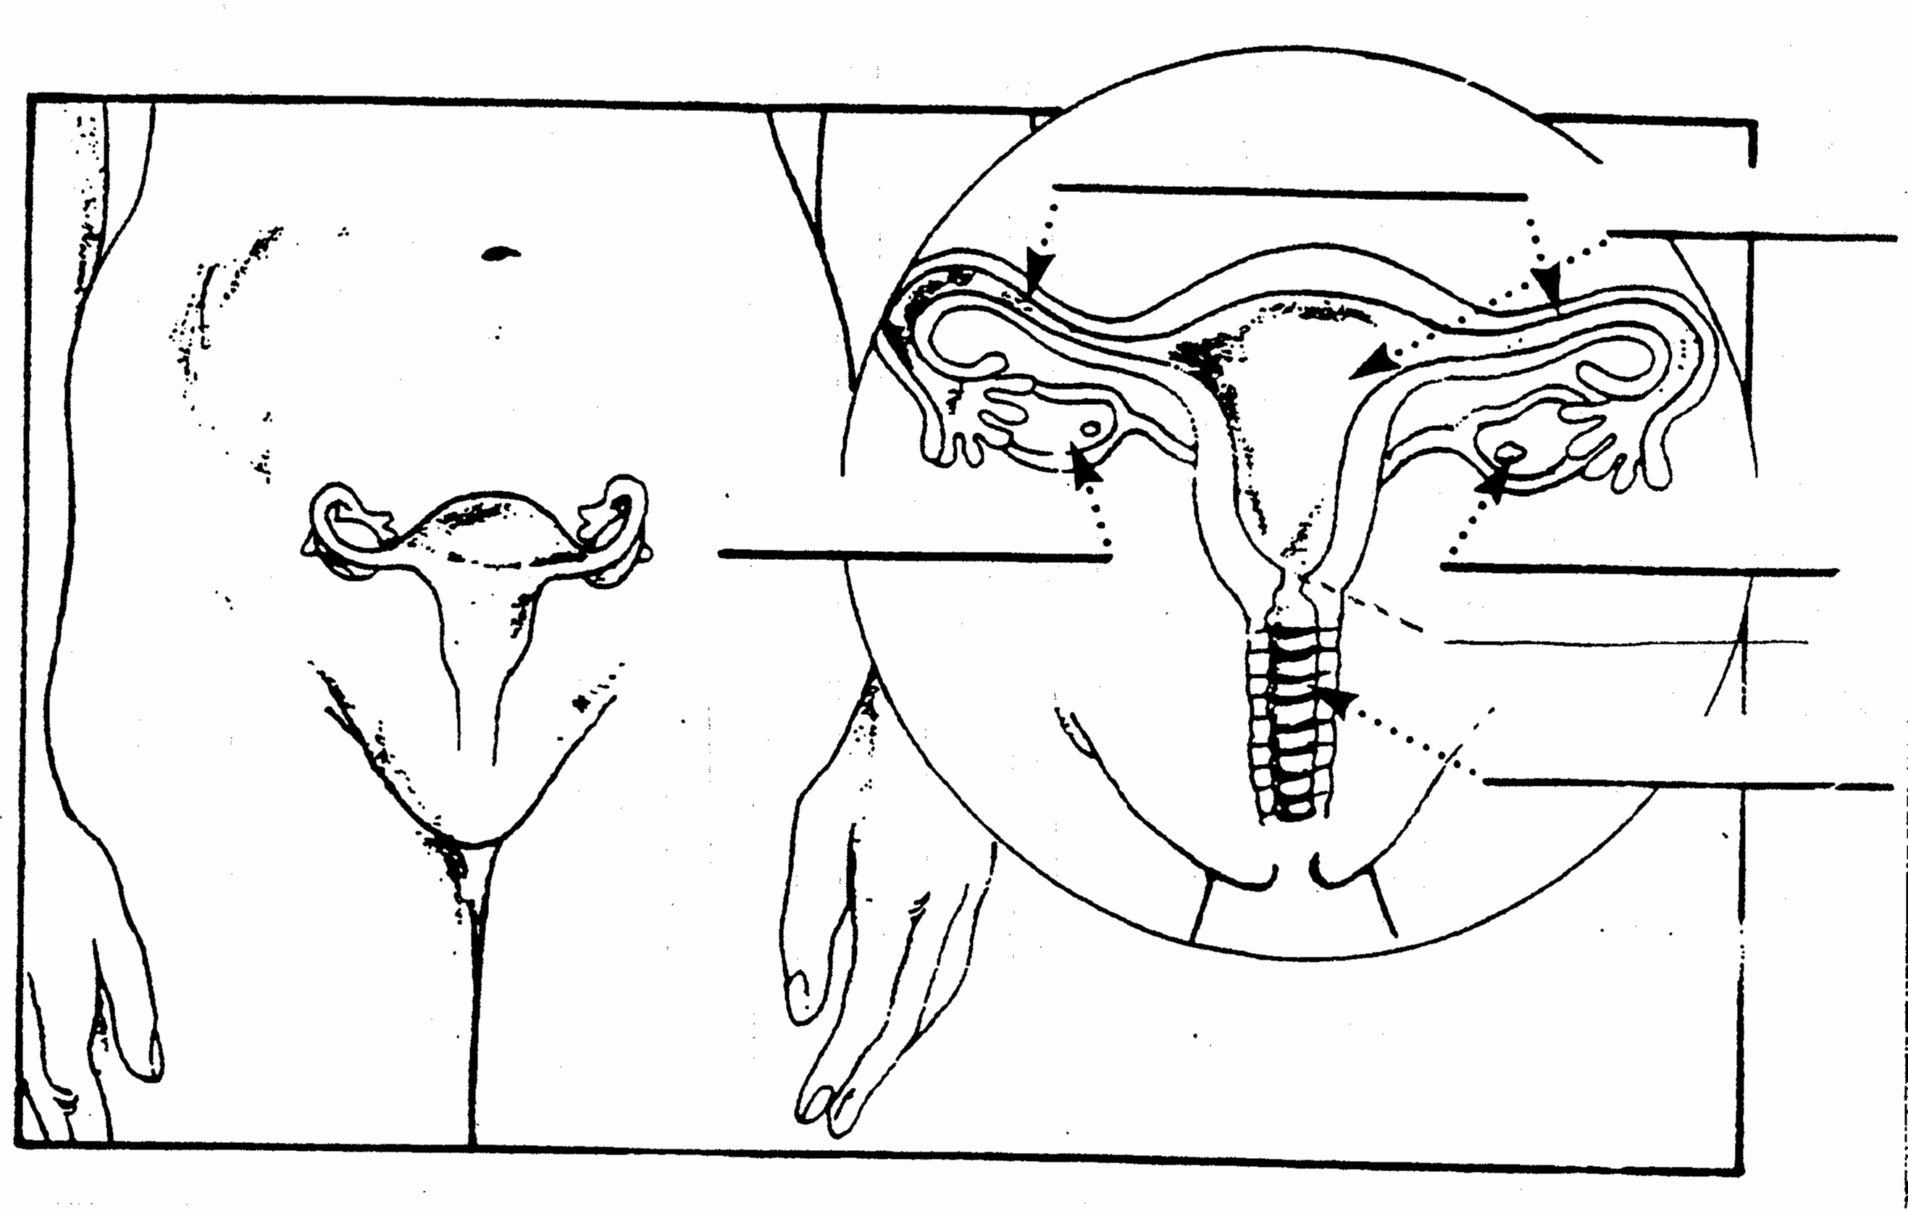

In-class Activity 3.5

Structure | Function
Ovaries | Produce ovum (eggs) and secrete hormones.
Urethra | Serves as a passageway for urine.
Fallopian Tube | Tube leading from the ovaries to the uterus. Ovum passes through here. Site of female fertilization.
Uterus | The female organ/muscle in which an embryo/fetus grows and develops.
Vagina | 3 Major functions:  - Female organ during intercourse  - Birth Canal  - Passageway for menstrual flow and arriving sperm
Labia (Major & Minor) | Covers and protects the vaginal opening.
Clitoris | Small, highly sensitive area between the labia. Site of female excitement.
Cervix | Lower opening of the uterus. Allows for passage of sperm and menstrual flow.
The Reproductive System
In-class Activity 3.6

The future of life itself depends upon the reproductive system. Each of the 20 definitions related to human reproduction is followed by a term. If the term matches the definition circle the term. If it does not, cross it out, and write the correct term in the space provided.

- Reproductive organs. | Genitals | ______________
- The male sex organ. | Scrotum | ______________
- The female sex organ and birth canal. | Vagina | ______________
- The male organ that produces sperm. | Urethra | ______________
- The fleshy sac that contains the testicles. | Sperm | ______________
- The external female genitals covering the vagina. | Uterus | ______________
- The pear-shaped organ, also called the womb, in which the growing baby develops. | Cervix | ______________
- Duct that carries sperm from the testicles. | Vas Deferens | ______________
- The female reproductive organs that produce eggs. | Ovaries | ______________
- The liquid that contains male sex cells. | Semen | ______________
- The tube that carries urine from the male’s bladder and sperm from the testicles. | Fallopian Tube | ______________
- Narrow opening at the neck of the uterus. | Labia | ______________
- Tubes that carry the female’s eggs from the ovaries to the uterus. | Testicle | ______________
- Male sex cell. | Penis | ______________
- Release of the egg from the ovary. | Menstruation | ______________
- Male gland near the bladder that produces the fluid part of semen. | Prostate | ______________
- Another name for the fallopian tube. | Urethra | ______________
- Shedding the lining of the uterus when the egg does not become fertilized. | Ejaculation | ______________
- The discharge of the male sperm. | Ovulation | ______________
Lesson 4 - More Changes
Lesson Outline 4.0

Health Standards:
- Students will comprehend concepts related to health promotion and disease prevention.
- Students will demonstrate the ability to practice health-enhancing behaviors and reduce health risks.
- Students will analyze the influence of culture, media, technology, and other factors on health.
- Students will demonstrate the ability to use interpersonal communication skills to enhance health.

Objectives:
- To promote understanding of emotional changes in adolescence, especially sexual attraction, and to promote positive ways of dealing with emotions.

Vocabulary:

Sexual Attraction: _______________________________________________ ____________________________________________________________________________________________________________________________

Mood: ________________________________________________________ ____________________________________________________________________________________________________________________________
Turn Ons
Male Female
In-class Activity 4.3

What turns men ON…

What turns women ON…

What turns men OFF…

What turns women OFF…

Questions for Small Groups
In-Class Activity 4.1
[To be copied and cut up for distribution to groups]

- What is the difference between having a crush on someone vs. “being in love”?
- How can people tell if they’re in love?
- Do you think it’s possible for someone your age to be “in love”? Why or Why not?
- Do you think most people marry the person that they’re in love with when they’re 13? Why or Why not?
- For people your age, do you think it’s a good idea to have sex if they’re attracted to someone? Why or Why not?
Sexism…Where do I find it?
Home Activity 4.2
- Describe what you think sexism is.
- Ask a female adult (a parent or teacher) to tell about a time when she was treated unfairly in a school situation or a job situation because she is female. Describe the situation.
- Find examples (stories, TV shows, magazine ads) that show men doing things that are traditionally women’s roles, and find examples of women filling traditional men’s roles.
- Describe one TV commercial or magazine that assumes that women do housework while men have jobs outside the home. How do these assumptions show sexism to both men and women?
- Copy down one thing you have heard people in your school say (in the halls, in a class) that you think discriminates against or “puts down” either girls or boys.
Sexism … What is it?
Bring to the next class two definitions of sexism. These definitions may be your own, a dictionary definition, or from a parent or other adult.
Extra Credit Activity 4.4

Definition 1:

Source of Definition 1: ___________________________________________

Definition 2:

Source of Definition 2: ___________________________________________
Chapter Outline 5.0
Lesson 5 - Equal Though Different

Health Standards:
- Students will comprehend concepts related to health promotion and disease prevention.
- Students will demonstrate the ability to practice health-enhancing behaviors and reduce health risks.
- Students will analyze the influence of culture, media, technology, and other factors on health.
- Students will demonstrate the ability to use interpersonal communication skills to enhance health.
- Students will demonstrate the ability to advocate for personal, family, and community health.

Objectives:
- To promote equality and social justice for human beings, regardless of gender.

Vocabulary:

Sexism: _______________________________________________________ ____________________________________________________________________________________________________________________________

Sex-role: ______________________________________________________ ____________________________________________________________________________________________________________________________

Stereotype: ____________________________________________________ ____________________________________________________________________________________________________________________________
Personality Traits
In-Class Activity 5.4
Trait | Male | Female
Aggressive
Athletic
Brave
Competitive
Emotional
Gentle
Helpless
Independent
Intelligent
Loving
Persuasive
Reliable
Responsible
Sensitive
Strong
Talkative
Thoughtful
Tough
Understanding
Sexism and Sex Role
Stereotyping
In-Class Activity 5.1
Quickly read through each statement and put a mark in the box which best fits your opinion. Your choices are Strongly Agree, Agree, Disagree and Strongly Disagree.

- It’s really the woman’s job to stay home and raise the kids.
- Girls should be able to ask guys out.
- Boys’ athletics are really more important than girls’.
- Men sometimes treat women like objects.
- Men make good secretaries and nurses.
- Boys should hide their feelings if at all possible.
- If a husband and wife both work, they should both help with the cooking and cleaning at home.
- Girls have more feelings than boys.
- Men are really more intelligent than women.
- The husband should have the final say.
- It’s just as OK for men to cry as for women.
- Girls should help pay for dates.
- Education is more important for boys than for girls.
- Women make good construction workers and engineers.
- Boys should learn how to cook, sew, clean a house and do laundry.
SA A D SD
- ◻ ◻ ◻ ◻
- ◻ ◻ ◻ ◻
- ◻ ◻ ◻ ◻
- ◻ ◻ ◻ ◻
- ◻ ◻ ◻ ◻
- ◻ ◻ ◻ ◻
- ◻ ◻ ◻ ◻
- ◻ ◻ ◻ ◻
- ◻ ◻ ◻ ◻
- ◻ ◻ ◻ ◻
- ◻ ◻ ◻ ◻
- ◻ ◻ ◻ ◻
- ◻ ◻ ◻ ◻
- ◻ ◻ ◻ ◻
- ◻ ◻ ◻ ◻

My Influences
Homework Activity 5.2
Write a paragraph about how the media influences how you treat the opposite sex positively and negatively. If they don’t, how could they?

____________________________________________________________________________________________________________________________

______________________________________________________________

______________________________________________________________

______________________________________________________________

______________________________________________________________

______________________________________________________________

______________________________________________________________

____________________________________________________________________________________________________________________________

______________________________________________________________

______________________________________________________________

______________________________________________________________

______________________________________________________________

______________________________________________________________

Extra Credit Activity 5.3

Example of Sexism
Bring to the next class one example of sexism. If it is a cartoon, ad or article in a newspaper or magazine, cut it out and bring it. If it is a TV commercial, a video, part of a movie, a billboard, or something else not portable, describe it in writing in the space below. Regardless of how what your example is, please provide one paragraph explanation below as to why it is sexism and your reaction to it.

____________________________________________________________________________________________________________________________

______________________________________________________________

______________________________________________________________

______________________________________________________________

______________________________________________________________

____________________________________________________________________________________________________________________________

______________________________________________________________

____________________________________________________________________________________________________________________________

______________________________________________________________

______________________________________________________________

______________________________________________________________

Lesson 6 - Making Choices
Lesson Outline 6.0

Health Standards:
- Students will comprehend concepts related to health promotion and disease prevention.
- Students will demonstrate the ability to practice health-enhancing behaviors and reduce health risks.
- Students will analyze the influence of culture, media, technology, and other factors on health.
- Students will demonstrate the ability to use goal-setting and decision-making skills to enhance health.

Objectives:
- To help adolescents understand that choices are involved in most situations and that, in making choices, it is helpful to thing about basic human values and possible consequences of choices.

Vocabulary:

Decision: ______________________________________________________ ____________________________________________________________________________________________________________________________

Consequence: __________________________________________________ ____________________________________________________________________________________________________________________________

Choices  In-class Activity 6.1 | Consequences

_____________________________________________________________
________________________________________________________________________________________________________________________________________________________________________________________________________________________________________________________

Lesson 7 - Going Out?
Lesson Outline 7.0

Health Standards:
- Students will comprehend concepts related to health promotion and disease prevention.
- Students will demonstrate the ability to practice health-enhancing behaviors and reduce health risks.
- Students will analyze the influence of culture, media, technology, and other factors on health.
- Students will demonstrate the ability to use interpersonal communication to enhance health.
- Students will demonstrate the ability to use goal-setting and decision-making skills to enhance health.

Objectives:
- To explore various aspects of dating and to develop guidelines contributing to positive growth.

Vocabulary:

Dating: _______________________________________________________ ____________________________________________________________________________________________________________________________

Peer Pressure: __________________________________________________ ____________________________________________________________________________________________________________________________

Risky Situation: ________________________________________________ ____________________________________________________________________________________________________________________________
Parents’ Ideas and Expectations
about Dating
Homework Activity 7.1
Interview your parents or adult partner with these questions. Record their answers, and bring to the next class.

- Why do people date?
- What is a good age to begin dating? Why?
- Who should do the asking? Why?
- Who should pay for the date? Why?
- List some guidelines on whom to date? (Example: same age)
- What are the advantages of a group date? (Example: a whole group of boys and girls go to the movies)
- How late do YOU think it’s okay to be out on a date? Weekend? Week night? Why?
- Keeping guidelines in mind, what dating situations could be difficult to handle (risky situations)? What makes these situations risky?

Parent Signature: ________________________________________________

Choosing Abstinence
Video 6
In-class Activity 8.1
Preview
- What would you do if someone pressured you to have sex? What would you say?
__________________________________________________________________________________________________________________________________________________________________________________________

Explore
- List two significant risks of being sexually active.
____________________________________________________________________________________________________________________________
- What reasons did Zach and Chelsey give for choosing abstinence?
__________________________________________________________________________________________________________________________________________________________________________________________

- How did belonging to a group of teens that shared their values help Zach and Chelsey to keep their commitment?
__________________________________________________________________________________________________________________________________________________________________________________________
- Why do you think Kyle was emotionally devastated even though she was the one who ended her relationship with her boyfriend?
__________________________________________________________________________________________________________________________________________________________________________________________
- Do you think that it will be difficult for Angel to “be single for quite a while”? Why or why not?
__________________________________________________________________________________________________________________________________________________________________________________________
- What are some advantages of going out as a group?
__________________________________________________________________________________________________________________________________________________________________________________________
Wrap Up
- What advice would you give a friend about how to abstain from sex?
__________________________________________________________________________________________________________________________________________________________________________________________

Connect to Your Life
- Describe three things you learned from the video about the benefits of abstinence.
______________________________________________________________________________________________________________________________________________________________________________________________________________________________________________________________________________________________________________________

Lesson 9 - Pregnancy & Birth
Lesson Outline 9.0

Health Standards:
- Students will comprehend concepts related to health promotion and disease prevention.
- Students will demonstrate the ability to practice health-enhancing behaviors and reduce health risks.
- Students will demonstrate the ability to use goal-setting and decision-making skills to enhance health.

Objectives:
- To promote understanding of fetal growth and development, maternal changes, the process of labor and birth, and the influence of the mother’s health on the well being of the baby.

Chapter 9 Vocabulary
Amniotic Sac – bag of ________; a sac developed in ________ inside the uterus containing ________ fluid. This fluid helps ________ the baby during pregnancy.
In-class Activity 9.4
Caesarean Birth (C-section) – birth of a baby through an ________ in the abdomen. This occurs when birth through the ________ is not possible or would not be________ .
Cervix – lower part of the ________ which opens or ________ during labor to allow the birth of the baby.
Conception – the beginning of ________ when an ________ cell from a female meets a ________ cell from a male.
Contraction – the tightening of a ________. During ________ the muscle that contracts is the ________. Also called ________ pains.
Dilation – the process of ________. In labor the ________ dilates or opens to a size of ________ cm in diameter to allow the baby to be pushed out of the ________ and into the ________.
Embryo – the ________ part of the life of a ________ baby. This period lasts from the time the ________ egg is a few ________ old until it has been growing for ________ weeks.
Fetus – the developing ________ from the ________ week of life in the uterus until ________.
Labor – regular ________________ of the uterus which ________ or ________ the cervix that allow the baby and ________ to be pushed out.
Placenta – also called ________; an organ which ________ in pregnancy inside the ________. It is attached to the ________ on one side and connected to the ________ by the umbilical cord. Food and ________ are received by the baby from the ________ through the cord and waste products are ________ in a similar way.
Umbilical Cord – tube containing ________ blood vessel that connects the ________ to the placenta.
Uterus – small ________ sac in the ________ body where the ________ grows during pregnancy; also known as the ________.
Vagina – the passage from the ________ of the body to the ________; also refers to the ________ of this muscular tube. Also known as the birth ________.

Pregnancy Video
In-class Activity 9.2

Answer these questions in complete sentences.
- How did the video make you feel?
__________________________________________________________________________________________________________________________________________________________________________________________

- Was the birthing film what you imagined?
__________________________________________________________________________________________________________________________________________________________________________________________
- What do you think would be the most difficult part of pregnancy and birth?
__________________________________________________________________________________________________________________________________________________________________________________________
- For the girls: How do you feel about the fact that women give birth?
__________________________________________________________________________________________________________________________________________________________________________________________
- For the boys: How do you feel about the fact that women give birth?
__________________________________________________________________________________________________________________________________________________________________________________________

My Birth
Homework Activity 9.1a
If you are now living with your natural parents, interview the person who can best answer these questions, writing your answers in the space provided.

- Place of Birth (city, hospital, etc.)
- Time of Birth (weather, historical events at the time)
- Where were they when labor began?
- How long was labor?
- People present (family, medical personnel, others)?
- Weight at Birth?
- Any unusual happenings?
- How did they pick your name?
- What were the first six months like? First year?
- Ask the questions you would like to know about your birth and early childhood, such as diseases, first steps, first words, etc.
- What sources of information about yourself are available to you? For example, baby books, family records, albums, photos, traditional stories…
My Birth
If you are adopted or not living with your natural parents, interview the person who can best answer these questions, writing your answers in the space provided.
Homework Activity 9.1b

- What do they know about your birth?
  - Where was it?
  - Time (What was happening in the world at the time?)
  - Weight, length, etc.
- What was it like the first time they saw you? How long had they known you were coming to live with them?
- Ask about the day you came to live with them.
- What were your first six months together like?
- What can they tell you about your name?
- What do they know about your early life (your first words, childhood illnesses, etc.)?
- What sources of information are available (for example: baby books, records, photographs…)?

Lesson 10 - Planning for the Future
Lesson Outline 10.0

Health Standards:
- Students will comprehend concepts related to health promotion and disease prevention.
- Students will demonstrate the ability to access valid health information and health promoting products and services.
- Students will demonstrate the ability to practice health-enhancing behaviors and reduce health risks.
- Students will demonstrate the ability to use goal-setting and decision-making skills to enhance health.
- Students will demonstrate the ability to advocate for personal, family, and community health.

Objectives:
- To promote abstinence as the best method of avoiding pregnancy for teens and to provide information on other available family planning methods.

Vocabulary:

Abstinence: ____________________________________________________ ____________________________________________________________________________________________________________________________

Birth Control (Contraception): _____________________________________ ____________________________________________________________________________________________________________________________

Effectiveness: __________________________________________________ ____________________________________________________________________________________________________________________________

In-class Activity 10.1

Jot down 10 goals you want to do in the future.

- ________________________________________________________
- ________________________________________________________
- ________________________________________________________
- ________________________________________________________
- ________________________________________________________
- ________________________________________________________
- ________________________________________________________
- ________________________________________________________
- ________________________________________________________
- ________________________________________________________

Now, suppose you became pregnant or fathered a child while you were still in school.
  - Would these things still be possible for you?
  - Would your plans have to change?
Answer the following questions:
- If or when you get married, do you want to have children?
_________________________________________________________
- If you answered yes, what age do you want to be when you have your first child?
_________________________________________________________

In-class Activity 10.2

People make plans all the time. What are some things you plan for?
- _________________________________________________________
- _________________________________________________________
- _________________________________________________________
- _________________________________________________________
- _________________________________________________________

Let’s look at HOW people plan…
- LOOK AHEAD
- LOOK AT CHOICES
- LOOK AT DECISIONS
- DECIDE
- FOLLOW THROUGH
  - Why do people plan?
__________________________________________________________________________________________________________________
  - What happens if you don’t plan?
__________________________________________________________________________________________________________________

The Age I Want to
Start Having Children
In-class Activity 10.3

13 – 15
16 – 18
19 – 20
21 – 23
24 – 26
27 – 29
30 – 33
34 – 36
37 +
In-class Activity 10.4

Abstinence is the ONLY 100% sure way to prevent pregnancy. That means, if someone really doesn’t want to become pregnant, not having sex is the only way of being absolutely certain.

In-class Activity 10.5

Almost everyone agrees that abstinence is the smartest choice for teenagers, but in spite of that fact, not everyone chooses abstinence. Sometimes people choose to have sex but don’t want a pregnancy to result. This is where birth control comes in. Birth control is a way to plan families used by many married couples. There are many different kinds of birth control available. You’ve probably heard of some of them.

Some teenagers do NOT choose abstinence and do NOT use birth control. What do you think are some reasons for this?
- ________________________________________________________
- ________________________________________________________
- ________________________________________________________

- ________________________________________________________

- ________________________________________________________

- ________________________________________________________

- ________________________________________________________

- ________________________________________________________

- ________________________________________________________
- _______________________________________________________

Remember, an important step to planning is to look at the consequences. If teenagers have sex and don’t use birth control, the consequences are really scary and huge. An unplanned pregnancy will really have a big effect on their plans for the future.

Lesson 11+12 - Teenage Pregnancy
Lesson Outline 11+12.0

Health Standards:
- Students will comprehend concepts related to health promotion and disease prevention.
- Students will demonstrate the ability to practice health-enhancing behaviors and reduce health risks.
- Students will demonstrate the ability to use goal-setting and decision-making skills to enhance health.

Objectives:
- To provide an understanding of the consequences of teenage pregnancy and the choices involved.

Vocabulary:

Adoption: _____________________________________________________ ____________________________________________________________________________________________________________________________

Pregnancy Complications: ________________________________________ ____________________________________________________________________________________________________________________________

Single Parenthood: ______________________________________________ ____________________________________________________________________________________________________________________________

What responsibilities does being a parent involve?

What are the basic needs of an infant?__________

Shared?!?

In-class Activity 11.1

Answer these questions after completing your diagram above:

- What qualities does a parent need in order to meet an infant’s needs?
__________________________________________________________________________________________________________________________________________________________________________________________

- In what ways does having a baby affect the rest of the family?
__________________________________________________________________________________________________________________________________________________________________________________________

Did you know…?
- More than 1 million teenage girls get pregnant each year.
- Four out of every ten teenage girls will get pregnant before the age of 20, if the present trends continue.

In-class Activity 11.2
Group Names: __________________________________________________
__________________________________________________

Try to list as many effects of Teenage pregnancy that your group can think of.
Example: The mother will most likely raise the baby as a single parent.
Effects of Teenage Pregnancy
________________________________________________________________________________________________________________________________________________________________________________________________________________________________________________________________________________________________________________________________________________________________________________________________________________________________________________________________________________________________________________________________________________________________________________________________________________________________________________________________________________________________________________________________________________________________________________________________________________________________________________________________
Some Effects of Teenage Pregnancy
In-class Activity 11.3
The teen father may drop out of high school to get a job to support the baby.
The relationship between the pregnant girl and teen father may not last. If it doesn’t, it will be difficult for her to handle the responsibilities alone.
Finances can be a big problem. A teenage couple or an adolescent on her won often cannot afford the expenses of a baby. The costs of delivery, medical care, formula, diapers, clothing, and more are very high.
Living arrangements for the young parent may be a problem. Not all teenage parents can live with their families. Finding an apartment, living alone, and coping with all the tasks of running a household are difficult.
For teen mothers living at home, there can be conflicts between the teenager and her parent(s). Teenage pregnancies affect the whole family, not just the teenager.
A young baby requires a huge amount of patience, time and commitment. Babies need to be waited on for all of their needs. Often a teenager can’t handle a baby’s needs and her own at the same time. Babies are often neglected or abused because of the stresses involved in a teen pregnancy. Babies need to be held, touched, played with, and cared for.
It is inspected that babies born to teenagers have a greater chance of dying from Sudden Infant Death Syndrome (SIDS/Crib Death)
Teenage Pregnancy Facts
Most teens who become pregnant don’t marry.
In-class Activity 11.4
Most teens that have babies don’t place them for adoption.
Babies born to teen mothers have a greater risk of medical problems (may be born too soon, weigh too little, and have other problems). Low birth weight babies are at greater risk of cerebral palsy, epilepsy and mental retardation.
A teenage mother is more likely to have complications during pregnancy than a woman over 18 years of age.
The risk of death for a pregnant teen is higher than for a woman in her twenties.
Most teen mothers do not complete high school nor acquire employment skills and are more likely to end up on welfare.
Many teens will have a second pregnancy before the age of 20.
Many teens do not seek medical care until late in pregnancy, thereby increasing the health risks to both mother and child.
If a teenage girl gets pregnancy, very often the boy leaves her.

Pretend that you are a 16 year old who has just given birth to a child or fathered a child. What are some positives and negatives about the following choices?
In-class Activity 11.5
 | Positives | Negatives
Option #1 – Keeping the baby and staying single.

Option #2 – Keeping the baby and getting married.

Option #3 – Placing the baby up for adoption.

- What choice do you think your family would suggest?

- What choice do you think your friends would suggest?

Teenage Parenting
In-class Activity 12.1
Pretend that you are 16 years old and you just found out that you are pregnant, or have fathered a child.

- Think about all the choices available in your own personal situation. What would be difficult about keeping the baby and becoming a single parent?
____________________________________________________________________________________________________________________________________________________________________________________
Getting married and keeping the baby?
____________________________________________________________________________________________________________________________________________________________________________________
- Now think about your family. How might your family feel about the pregnancy?
____________________________________________________________________________________________________________________________________________________________________________________
- What choice do you think your family would suggest for you? Why?
____________________________________________________________________________________________________________________________________________________________________________________
- What choice do you think your friends might suggest? Why?
____________________________________________________________________________________________________________________________________________________________________________________
- List some people or places you could go to for help.
  - _________________________________________________________
  - _________________________________________________________
  - _________________________________________________________
  - _________________________________________________________

Teenage Pregnancy
Video 19
In-class Activity 12.3
Preview
- What are some of the difficulties teenage parents face?
__________________________________________________________________________________________________________________________________________________________________________________________

Explore
- What challenges did Kristine face after her son was born? What ended up happening to her son?
____________________________________________________________________________________________________________________________
- What does Amy miss most about the life she led before her son was born? What help would you offer Amy if she were your friend?
__________________________________________________________________________________________________________________________________________________________________________________________

- Why is it important for pregnant teens in particular to get prenatal care as soon as they know they are pregnant?
__________________________________________________________________________________________________________________________________________________________________________________________
- What assistance do Doulas and other healthcare providers offer pregnant teens?
__________________________________________________________________________________________________________________________________________________________________________________________

- Do you think parents should get more support from government or community organizations? Why or why not?
__________________________________________________________________________________________________________________________________________________________________________________________
Wrap Up
- What kind of support do teenagers parents need?
__________________________________________________________________________________________________________________________________________________________________________________________

Connect to Your Life
- Describe how pregnancy affected the long-term plans of the teens in the video.
______________________________________________________________________________________________________________________________________________________________________________________________________________________________________________________________________________________________________________________

Lesson 13 - Taking Chances
Lesson Outline 13.0

Health Standards:
- Students will comprehend concepts related to health promotion and disease prevention.
- Students will demonstrate the ability to access valid health information and health promoting products and services.
- Students will demonstrate the ability to practice health-enhancing behaviors and reduce health risks.
- Students will demonstrate the ability to use goal-setting and decision-making skills to enhance health.
- Students will demonstrate the ability to advocate for personal, family, and community health.

Objectives:
- To promote awareness of sexually transmitted disease as a possible consequence of sexual activity, along with knowledge of treatment and prevention.

Vocabulary:

Pelvic Inflammatory Disease (PID): _________________________________ __________________________________________________________________________________________________________________________________________________________________________________________

Venereal Disease (VD)/Sexually Transmitted Disease (STD): ____________ ____________________________________________________________________________________________________________________________

STD/STI Sense
In-class Activity 13.1

Beginning of Class

TRUE FALSE
_____ _____

_____ _____

_____ _____

_____ _____

_____ _____

_____ _____

_____ _____

_____ _____

_____ _____

_____ _____

- A person with herpes can be completely cured with proper medical treatment.
- It is easier for girls than for boys to tell if they have an STD/STI.
- STD/STI s are not all that serious.
- A person with one sex partner is as likely to get an STD/STI as a person with ten partners.
- STD/STI s can result in a baby being born blind.
- If a girl thinks a guy has an STD/STI, it is stupid to have sex with him.
- One consequence of having an STD/STI might be the inability to have children.
- A girl is really being unfair if she suspects she has an STD/STI and doesn’t tell her boyfriend until after they have had sex.
- STD/STI s among teenagers are really pretty rare.
- In our state, parents need to be notified if their son or daughter is treated for an STD/STI.
End of Class

TRUE FALSE
_____ _____

_____ _____

_____ _____

_____ _____

_____ _____

_____ _____

_____ _____

_____ _____

_____ _____

_____ _____

Sexually Transmitted Diseases/Infection (STD/STIs)
Name | Facts | Symptoms | Results
Gonorrhea | Treatable with penicillin. Most women and some men have NO symptoms.  Spread only by sexual contact.  There is a super-strain now that is resistant to treatment. | Usually show up 2-6 days after sexual contact.  For men: pus dripping from penis or burning feeling while urinating; 10% have no symptoms.  For women: slight vaginal discharge with burning but usually no symptoms at all. | Sterility in men and women.  If a mother has gonorrhea when her baby is born, the baby must get medication or it may go blind.  Arthritis, heart trouble, and general bad health.  For women: one complication is an inflammation of the pelvic organs.
Herpes | Caused by herpes virus.  Has reached epidemic proportions in the U.S.  There is treatment but NO cure at this time. | Painful blisters on genitals, sometimes on thighs and buttocks. They last 7-28 days.  The sores will go away, but the disease will not. The sores can occur over and over again. Stress might be one reason for recurrence. | For women: The chance of getting cancer of the cervix is higher, so women with herpes should have regular pap smears.  Newborn babies can get herpes as they pass through the birth canal. Herpes can hurt the central nervous system and the baby could die.
Syphilis | Treatable with penicillin, antibiotics.  Spread only by sexual contact. | The first sign is a sore or “chancre.” It is very contagious and usually painless.  In men: it is on the penis.  In women: it is inside and around the vagina.  Chancres may also show up on the mouth or breasts and cause swelling in the groin. They disappear in 3-6 weeks.  The Second Stage:  About 1-6 months later, people with syphilis get flu symptoms: they are tired and feverish; their joints and muscles hurt. They might get a painless rash on the palms of their hands or soles of their feet, swollen lymph nodes and hair loss in patches.  The Third Stage:  (The latent or silent stage). The disease travels all over the body for 1-20 years. | If the mother is pregnant and the baby gets infected, it can die or be seriously hurt.  If the disease enters Stage 3, it can be very serious: brain damage, heart and blood vessel disease, kidney disease, and possible death.
(HPV) | Caused by human papillomavirus. No cure, only symptoms are treated. | Visible genital warts, precancerous changes in the cervix, labia, anus or penis.  Common to have no symptoms at all. | May increase the risk of certain types of cancer mainly cervical cancer. A mother can pass the infection to her baby during birth.
Pubic Lice (Crabs) | Insect makes its home in pubic hair area but can travel to other areas.  Can be passed on in many ways, including sexual contact.  Becoming more common.  Treatable. | Crabs are almost invisible and cause intense itching. | Harmless
Chlamydia | Very common STD.  Can cause several different types of infections, including NSU.  Treated with antibiotics. | For women: Itching, burning and discharge from vagina.  In men: painful urination.  Many men and women have no symptoms. | Can cause pelvic inflammatory disease (leading to infertility)  Miscarriages, stillbirths.  Newborns may get conjunctivitis or pneumonia if mother has infection while pregnant.
AIDS (Acquired Immune Deficiency Syndrome) | High risk groups: sexually active homosexual and bisexual men, IV drug users, hemophiliacs, certain immigrants to U.S. since 1977 and people who have sexual contact with any of the above.  Transmitted through body fluids (semen, blood). | Fatigue, loss of appetite, and extreme weight loss.  Swollen lymph glands all over the body.  Night Sweats.  Skin Infections that won’t heal. | Actually caused by HIV (Human Immunodeficiency Virus) that attacks the body’s immune system.  Most AIDS victims die within 2-4 years, though treatment has become more advanced in slowing the process of HIV allowing people to live longer.  AIDS victims don’t actually die from the syndrome itself, they are killed by common sicknesses which the immune system can no longer fight off.
Non-Specific Urethritis (NSU) or Non-Gonococcal Urethritis (NGU) | Very common STD in the U.S.  A painful inflammation of the urinary tract.  Treatable with antibiotics. | A clear or whitish gray discharge from the penis along with burning pain during urination.  22% of the men and most of the women have NO symptoms. | Prostrate problems, infertility, eye problems, skin outbreaks, and small ulcers in the mouth.  If a woman is pregnant, the baby can die or be seriously hurt.
Vaginal Infections | Passed during sexual contact. Mainly a women’s disease, but men can carry the germs and show symptoms, too.  Treatable. | Redness and itching of the vagina and a smelly discharge. These signs can go away, but the disease can stay. | In women: gland infections, more risk of cancer of the cervix.
Venereal Warts | Treatable by freezing or burning. Very contagious. | Warts on genitals that spread quickly. | May be linked to certain types of cancer.

Lesson 14 - The Power of Touch
Lesson Outline 14.0

Health Standards:
- Students will comprehend concepts related to health promotion and disease prevention.
- Students will demonstrate the ability to practice health-enhancing behaviors and reduce health risks.
- Students will analyze the influence of culture, media, technology, and other factors on health.
- Students will demonstrate the ability to use interpersonal communication skills to enhance health.
- Students will demonstrate the ability to advocate for personal, family, and community health.

Objectives:
- To promote an understanding of the difference between positive and abusive touch.

Vocabulary:

Abuse: ________________________________________________________ ______________________________________________________________

Incest: ________________________________________________________ ______________________________________________________________

Rape: _________________________________________________________ ______________________________________________________________

Victim: _______________________________________________________ ______________________________________________________________

Know How to Protect Yourself
In-class Activity 14.1
- Trust your feelings. If you’re feeling scared, confused, or just uncomfortable, there’s probably a good reason.
- Remember that you could be at risk. Anyone can be a victim. It’s easier to think about protecting yourself if you know that it could happen to you – not just to other people.
- Think about situations that could be or are unsafe. Avoid them, or make sure someone you trust is with you. Talk about it with someone you trust, too.
- Don’t be afraid to ask for help. If you’re in danger or afraid, it’s smart to ask someone for help. It’s not a sign of weakness. It’s just common sense.
- Don’t try to handle everything on your own. If something has happened to you, or if you’re afraid or confused, a counselor or another adult you really trust can help you talk through your feelings.
- Use common sense self defense rules. (The ones you’ve always heard):
  - Don’t walk alone at night
  - Don’t take rides from people you don’t know very well
  - Don’t hitchhike
  - And all the others; they make sense!!!
- Say what you mean and what you want. If someone is pressuring you, you can say no! If someone touches you in a way that you don’t like or that is confusing, leave and talk to someone about it. Don’t let friend stalk you into doing something that seems scary or unsafe. Trust your feelings.

