
Mrs. Romberger
8th Math – Course 3
8th Algebra 1
Geometry

Required Materials Each Day:
- 2 - inch ring binder
- Loose leaf paper
- 1 Set of Dividers
- PENCILS, PENCILS, PENCILS
- Eraser
- Agenda Book
- Calculator – TI 30Xiis (MUST HAVE!)
- Graphing Calculator – TI-84 Plus (Optional but suggested - Algebra classes)

Expectations of you:
- Be on time with expected materials each day.
- Be respectful of each other.
- Stay in your seat once the bell rings.
- Bathroom privileges are limited. Don’t abuse it.

What you can expect:
- Homework is given Monday through Friday.
- All grades are updated on E-School. You can access your grade daily.
- All assignments and upcoming tests/quizzes are listed on my school webpage.
- Your notes may be used on any QUIZ but NOT TESTS.
- Test/Quiz corrections may be done for bonus points IF you get the test/quiz SIGNED by your parent.

Grading Policy

Your overall grade is calculated by dividing the total points you earned by the total points possible. (Grades will be averaged up if they fall 0.5 or higher.)

90 – 100 % A
80 – 89 % B
70 – 79 % C
60 – 69 % D
59 % or below F

Homework Expectations

- Homework is given daily and is checked for completeness. Please be neat, try all problems and show your work.

- All assignments are listed on CANVAS.

No extra credit will be given except for test/quiz corrections. Take advantage of this, the points add up and it improves understanding.

Keep up with your grade, sign up for HOME ACCESS today. Forms are available in the office.

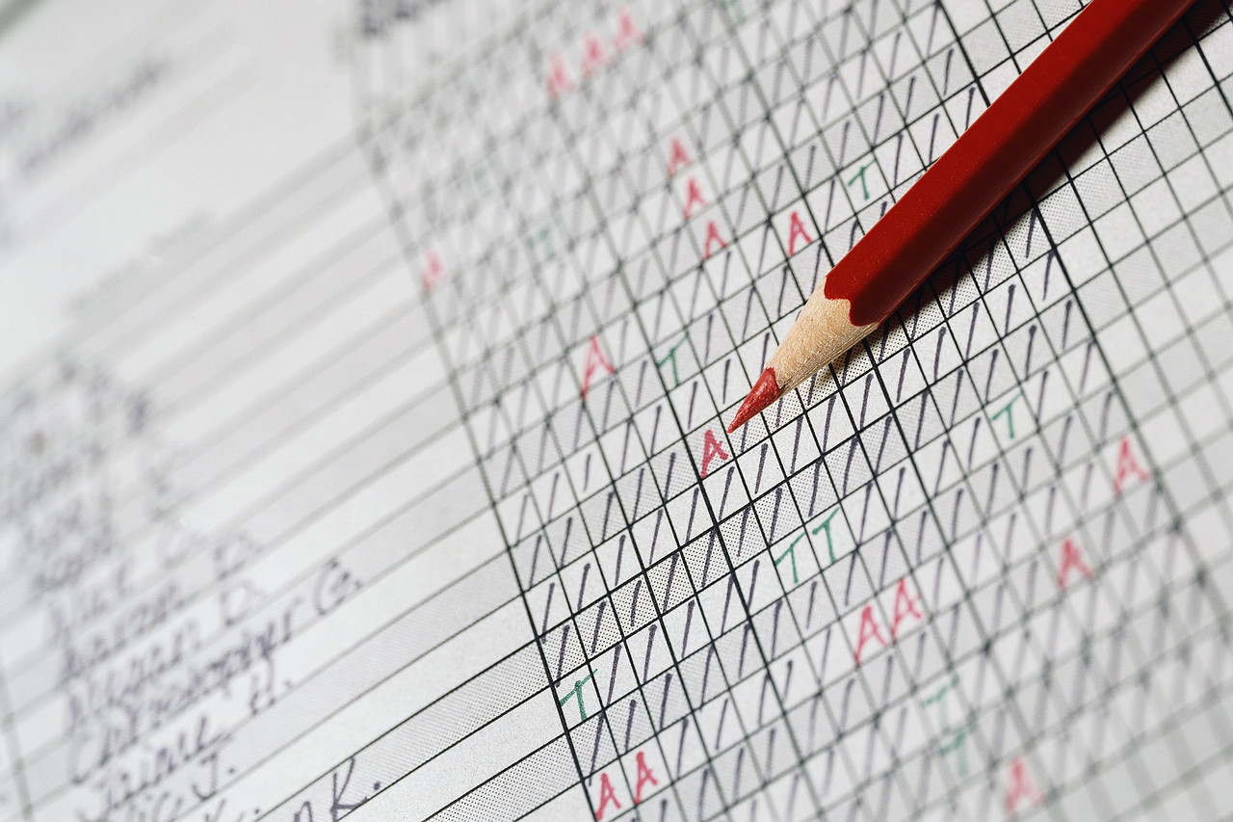

Absences

If you are absent, it is YOUR responsibility to find out exactly what you missed and to make up all work (class work, quizzes, tests, etc.) A.S.A.P



Math Notebook

You should have a 2 – inch three ring binder with dividers for math.

Labels for Dividers
VIP – Very Important Papers – ALL classes
Notes/CW – Note-taking, handouts, and class notes (Algebra & Geometry Classes)
HW – Homework assignments (Algebra & Geometry Classes)
T/Q – Test and Quizzes returned – ALL classes
PSSA – PSSA Preparation – ALL Classes
KS - Keystone Exam Preparation (ONLY Algebra classes)

Your notebook will serve as a tool used for VIP’s (very important papers), note-taking, assignment’s given, and your tests/quizzes returned.

All hand-outs should be placed in your binder immediately.

Be sure to always have extra loose leaf paper, and plenty of sharpened pencils.

Front Cover:
- First and Last Name
- Subject
- Mrs. Romberger
- Class Period



You may contact us at:
sromberger@neshaminy.com

