**Key Content Terms**

As you complete the Reading Notes, use these terms in your answers.

**R E A D I N G N O T E S**

archaeologist geographer prehistoric historian artifact ritual hominid fossil

**Section 1.2:** **Detectives Who Study the Past**

1. Complete the matrix below to compare the three social scientists you learned about in Section 2.

|  |  |  |  |
| --- | --- | --- | --- |
| **Type of**  **Social Scientist** | **What do**  **they do?** | **What questions**  **do they ask?** | **Symbol for**  **their work** |
|  |  |  |  |
|  |  |  |  |
|  |  |  |  |

2. In a complete sentence, answer the following question: How are social scientists like detectives?

____________________________________________________________________________________________

____________________________________________________________________________________________

**Section 1.3:** **Cave Art: Treasures of the Past**

1. List three things social scientists can learn from cave paintings.

____________________________________________________________________________________________

____________________________________________________________________________________________

____________________________________________________________________________________________

2. Sketch and label two artifacts that have been found in caves.

In this activity, you will try to discover what six cave artifacts reveal about early humans. Carefully examine each photograph from the cave. Match it to one of these images. Complete that section of the Reading Notes.

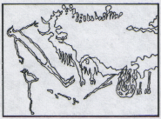**Transparency 1: Cave Painting of a Human**

**Find evidence:** Label ***three*** details in the image that may offer clues

about why the artist created this painting.

**Our hypothesis:** We think the artist created this because...

_________________________________________________________________

_________________________________________________________________

_________________________________________________________________

**Read Section 1.4.** Why do social scientists think this painting was created?

____________________________________________________________________________________________________

____________________________________________________________________________________________________

____________________________________________________________________________________________________

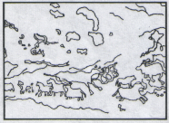**Placard 1A:**

**Find evidence:** Label ***two*** details in the image that may offer clues

about why the artist created this painting.

**Our hypothesis:** We think the artist created this because...

_________________________________________________________________

_________________________________________________________________

_________________________________________________________________

**Read Section 1.5.** Why do social scientists think this painting was created?

____________________________________________________________________________________________________

____________________________________________________________________________________________________

____________________________________________________________________________________________________

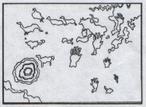**Placard 1B:**

**Find evidence:** Label ***three*** details in the image that may offer clues

about why the artist created this painting.

**Our hypothesis:** We think the artist created this because...

_________________________________________________________________

_________________________________________________________________

_________________________________________________________________

**Read Section 1.6.** Why do social scientists think this painting was created?

____________________________________________________________________________________________________

____________________________________________________________________________________________________

____________________________________________________________________________________________________

Carefully examine each photograph from the cave. Match it to one of these images. Complete that section of the RN.

**Placard 1C: Find evidence:** Label ***two*** details in the image that may offer clues about why the

artist created this tool.

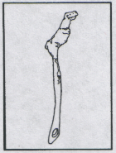

**Our hypothesis:** We think the artist created this because...

_____________________________________________________________________

_____________________________________________________________________

_____________________________________________________________________

**Read Section 1.7.** Why do social scientists think this tool was created?

_____________________________________________________________________

_____________________________________________________________________

_____________________________________________________________________

**Placard 1D: Find evidence:** Label ***two*** details in the image that may offer clues about why the

artist created these sculptures.

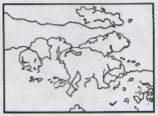

**Our hypothesis:** We think the artist created these because...

____________________________________________________________________

____________________________________________________________________

____________________________________________________________________

**Read Section 1.8.** Why do social scientists think these sculptures were created?

_____________________________________________________________________

_____________________________________________________________________

_____________________________________________________________________

**Placard 1E: Find evidence:** Label ***three*** details in the image that may offer clues about why the

artist created these tools.

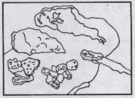

**Our hypothesis:** We think the artist used these tools to...

____________________________________________________________________

____________________________________________________________________

____________________________________________________________________

**Read Section 1.9.** What do social scientists think these tools were used for?

____________________________________________________________________

____________________________________________________________________

____________________________________________________________________