**Breakfast Sausage Casserole**

**adapted from Cooking Light magazine**

[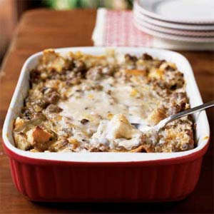](http://www.myrecipes.com/recipe/breakfast-sausage-casserole-0)

**Yield**

**8 servings**

**Sit overnight**

**Cook next day: 1 hour**

**Preheat oven to 350\***

**Ingredients:**

Cooking spray

1 (16-ounce) package frozen turkey sausage, thawed

8 (1 1/2-ounce) slices bread, cut into 1/2-inch cubes (about 8 cups)

2/3 cup (about 2 1/2 ounces) shredded sharp cheddar cheese

3 cups 1% low-fat milk, divided

4 eggs

1 tablespoon Dijon mustard

1 (10.75-ounce) can condensed reduced-sodium, fat-free cream of mushroom soup, undiluted

**Preparation:**

Heat a large nonstick skillet over medium-high heat. Coat pan with cooking spray. Add sausage to pan; cook 5 minutes or until browned, stirring well to crumble.

Arrange bread in a 13 x 9-inch baking dish coated with cooking spray. Top evenly with cooked turkey sausage and cheddar cheese. Combine 2 1/2 cups milk, eggs, and Dijon mustard, stirring with a whisk. Pour over bread mixture in dish. Cover and refrigerate 8 hours or overnight.

Uncover casserole. Combine remaining 1/2 cup milk and cream of mushroom soup, stirring with a whisk. Pour over bread mixture. Bake at 350° for 1 hour or until set and lightly browned. Let stand 15 minutes before serving.