Name: _________________________

Date: __________________________

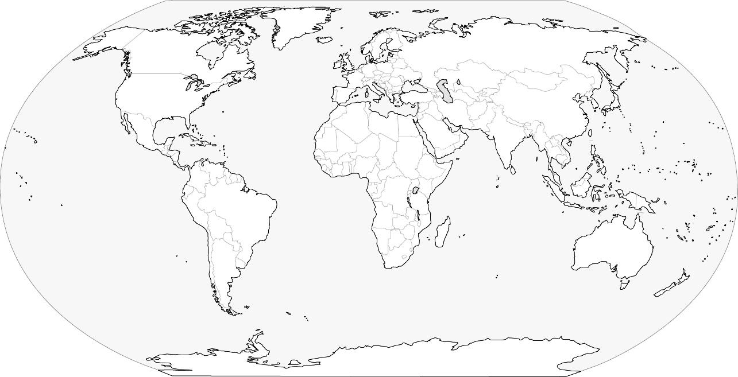

Name: _________________________

Date: __________________________

