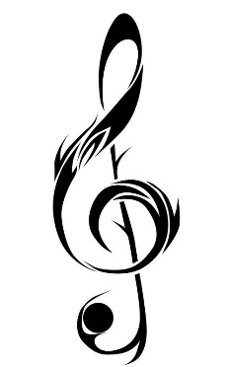Welcome to 5th Grade General Music!!

**Ms. Rhydderch**

**COURSE OUTLINE & THEME**

In this class we will continue to build upon the fundamentals of music that you’ve learned in elementary school and explore new concepts within the realm of music and in conjunction with the Pennsylvania State Standards for Music Education.

**CONTENT STUDIED THIS SEMESTER**

Music Fundamentals, Reading and Writing Rhythm & Pitch, Instruction and Performance on percussion instruments & recorders, music therapy, the study of musical genres within a Cultural Context, Music Technology, and other various music activities.

**COURSEWORK**

There will be **work sheets, performance based assessments, quizzes,** and **tests** for this class to determine your grade for each marking period.

Clinics are available during Tuesday mornings from 7:25am -7:50am with me in A-1 if extra help is needed in music.

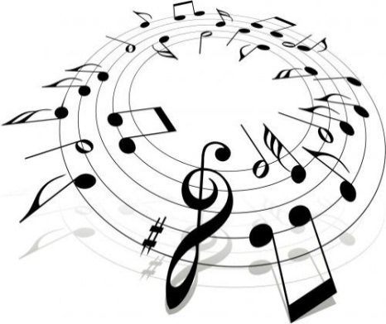

**MATERIALS**

Students are requiredto **bring in a folder, writing utensils, and blank sheets** of paper by Friday, September 8th, for their first grade of the semester. *There will be no extension on this assignment.* Students must come prepared to music every class. They will keep their folders in the music room.

**EXPECTATIONS**

Students are expected to participate appropriately in class and complete all work in the time frame given. Ample time will be given for each assignment. If you or your parents/guardians have any questions or concerns about general music or choir this semester please feel free to contact me via email [hrhydderch@neshaminy.k12.pa.us](mailto:hrhydderch@neshaminy.k12.pa.us) ☺

**I look forward to having a wonderful semester with you! ROCK ON!!**

**Ms. Rhydderch**