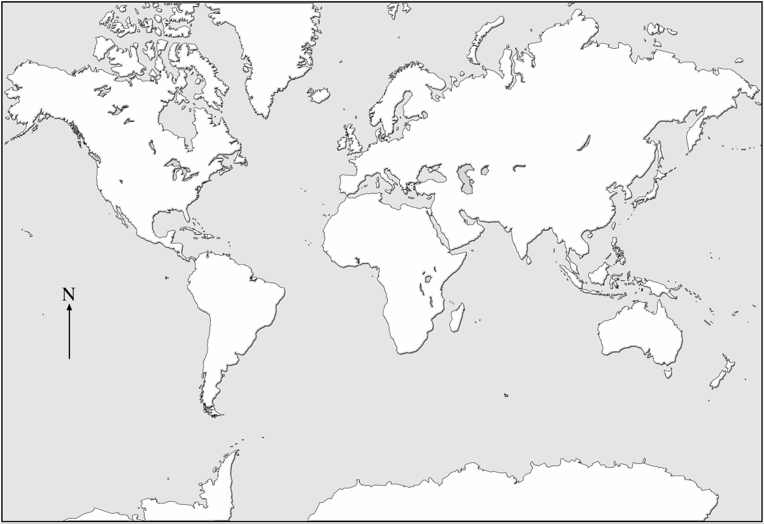

**Geo-Challenge Practice Map**