**HIP AND KNEE STRENGTHENING PROGRAM**

Many athletes suffer from hip and knee pain due to stress on the body; poor mechanics; and overuse. These 2 conditions can impact the other so it’s important to address both joints. The strengthening exercises and stretches listed below are to focus on the musculature around both the knee and the hip simultaneously.

**STRAIGHT LEG RAISES:** Work up to 3 sets of 10 for each exercise

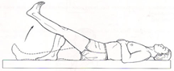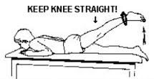

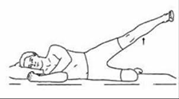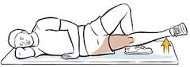

**Standing Hip/Knee Resistance:** Tie a resistance band around a post (or furniture leg). Perform each exercise – work up to 3 sets of 10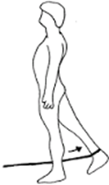

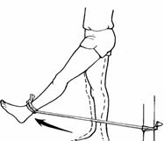

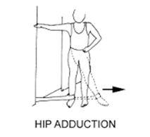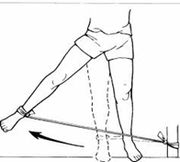

**Gluteus Medius Strengthening:**

Unlike the Gluteus Maximus, the Gluteus Medius is a muscle that gets overlooked when it comes to strengthening. In most cases, especially in the adolescent female athlete, a weak “Glute Med” is the main culprit resulting in hip and knee pain.

Do these exercises to help strengthen this particular muscle.

**Clam Shells & Reverse Clam Shells:** Loop a resistance band around your knees. Lay on your side and open your knees keeping your feet together. For the Reverse Clam Shell, move the resistance band to your ankles and open your ankles keeping your knees together. Work up to 3 sets of 10 for these -- and flip over so the other side gets work too!

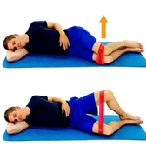 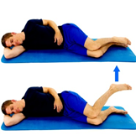

**Resistance Band Lateral Walking:** Loop a resistance band around your ankles. Get into an athletic stance and lateral walk (Side-step) 10 steps. Change direction and repeat 3x. Make sure your feet are facing forward and your step stride is no more than 2 feet. Maintain your athletic stance throughout.

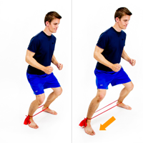

**FOAM ROLL & STRETCH!!!**

Refer to the ***FOAM ROLL Exercises*** on the Athletic Trainer webpage to roll out your leg muscles. Then perform the following stretches on each leg 3x for 20 seconds.

**IT BAND**

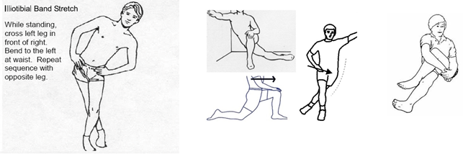

**GROIN (Adductors)**

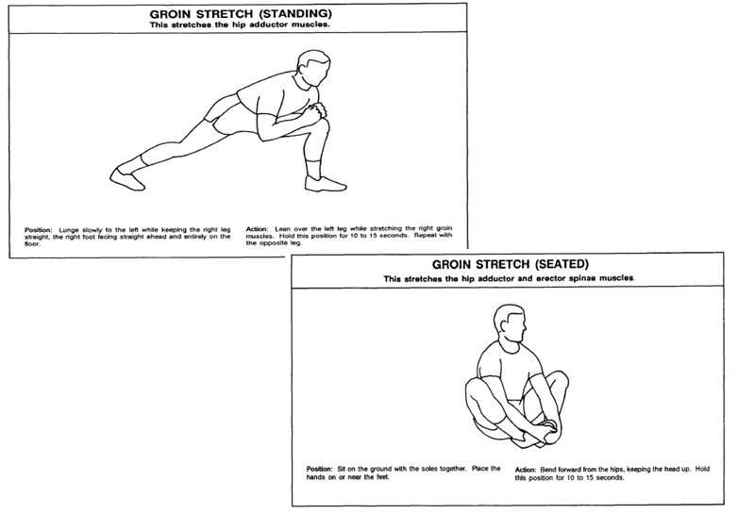

**QUADS/HIP FLEXORS**

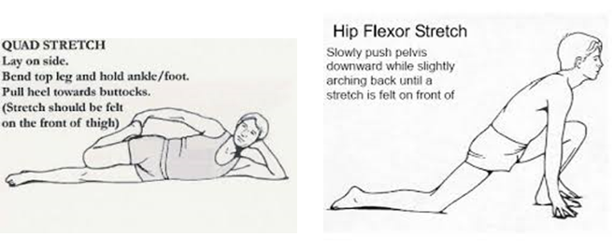

**HAMSTRINGS**

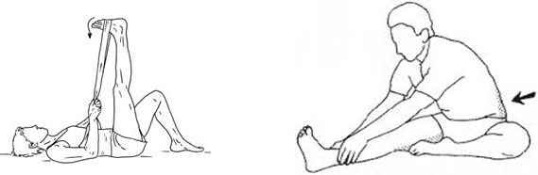

**GLUTES/PIRIFORMIS**

