Name _____________________________________ Date ____________ Period ____________

**“Marigolds” Constructed Response**

PROMPT: What is the theme of Eugenia Collier’s “Marigolds”?

How does the author use **setting** to develop this theme?

**What is required when using evidence in a constructed response?**

1. _____________________________________________________________________
2. _____________________________________________________________________
3. ______________________________________________________________________

**Step 1: Write your topic sentence. This is what you will prove through your writing.**

List as many topics from “Marigolds” as you can.

Turn one topic into a theme statement that includes the title and author of the story. (This should not include “I” “you” or “should.”)

**Step 2: Find your supporting evidence.**

**Quote #1**

|  |  |
| --- | --- |
| **Shirt**  (what is happening in story at time of quote) |  |
| **Quote**  (with page) |  |
| **Pants**  (how does this quote prove your topic sentence? |  |

**Quote #2**

|  |  |
| --- | --- |
| **Shirt**  (what is happening in story at time of quote) |  |
| **Quote**  (with page) |  |
| **Pants**  (how does this quote prove your topic sentence? |  |

**Step 3: Type your constructed response.** Be sure to use MLA format with an appropriate header. You should submit your document to TurnItIn upon completion.

This is how to set up your paper in MLA format. Be sure to type in Times New Roman, font size 12, and double space.

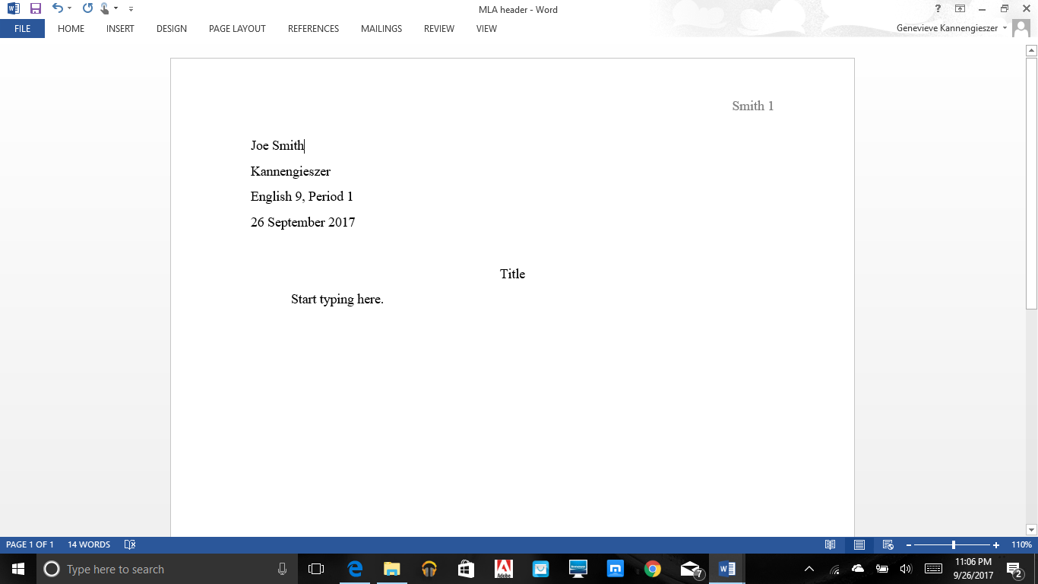

**Rubric: 60 points**

6 points – **Topic Sentence** – Introduce a precise, knowledgeable claim that is debatable, defensible, narrow, and specific. This should include the author and title of the piece, as well as the claim (in this case, theme developed through setting).

6 points- **Context for Evidence**- Provide context for quotation, addressing “where,” “when,” “what is going on in the text.”

6 points – **Evidence/Quote** – Supply sufficient relevant evidence from credible sources to fairly and thoroughly develop the claim. This should include a speaker tag and proper citation. –Character says, “Direct quote from story goes here” (Collier Page #).

6 points – **Analysis/Reasoning** – Use valid reasoning to **explain how the evidence** leads to the claim in your topic sentence.

6 points- **Context for Evidence**- Provide context for quotation, addressing “where,” “when,” “what is going on in the text.”

6 points – **Evidence/Quote** – Supply sufficient relevant evidence from credible sources to fairly and thoroughly develop the claim. This should include a speaker tag and proper citation. –Character says, “Direct quote from story goes here” (Collier Page #).

6 points – **Analysis/Reasoning** – Use valid reasoning to **explain how the evidence** leads to the claim in your topic sentence.

6 points – Proper **spelling, punctuation, capitalization**

6 points- Proper use of third person **point of view**. No first person “I.” No second person “you.”

6 points – Proper **MLA formatting**