**REPASO para el examen final de Español 2**

**8-A- De vacaciones**

Lugares para visitar Actividades de ocio

____________________________ ____________________________

____________________________ ____________________________

____________________________ ____________________________

____________________________ ____________________________

____________________________ ____________________________

Modos de transportación Frases para discutir experiencias

_______________________________ _______________________________

_______________________________ _______________________________

_______________________________ _______________________________

_______________________________ _______________________________

El pretérito de los verbos que El pretérito de los verbos ir y

terminan en –er y en –ir es: ser es:

|  |  |  |  |  |
| --- | --- | --- | --- | --- |
| **Singular** | **Plural** |  | **Singular** | **Plural** |
| **Yo** | **Nosotros** |  | **Yo** | **Nosotros** |
| **Tú** | **Ustedes** |  | **Tú** | **Ustedes** |
| **Él/ella** | **Ellos./as** |  | **Él/ella** | **Ellos./as** |

______________ se escribe antes del objeto directo si es una **persona**.

**Vocabulario y pretérito**

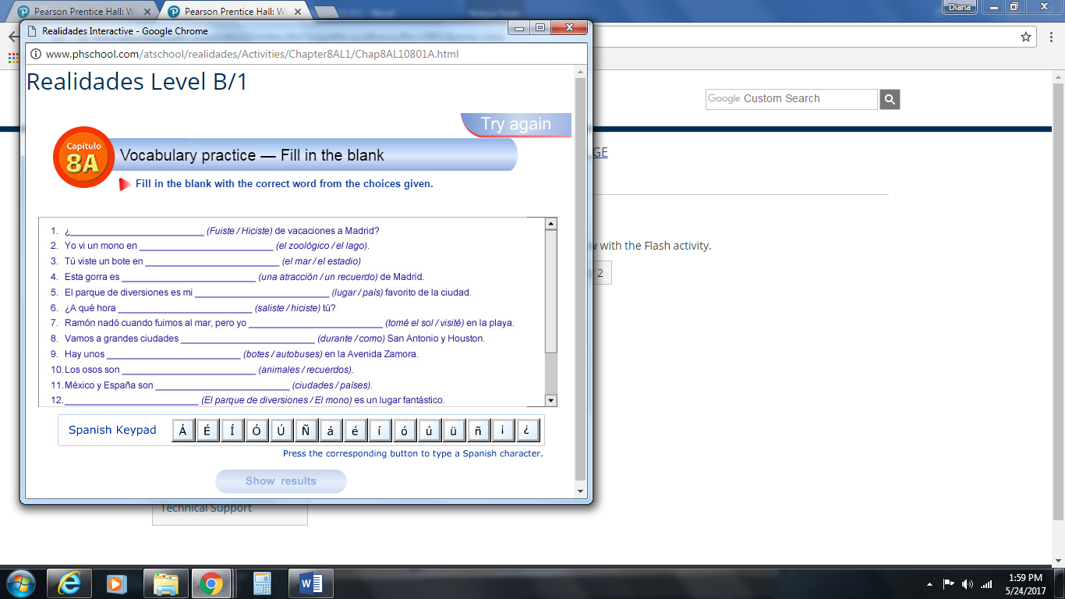

**Personal A**

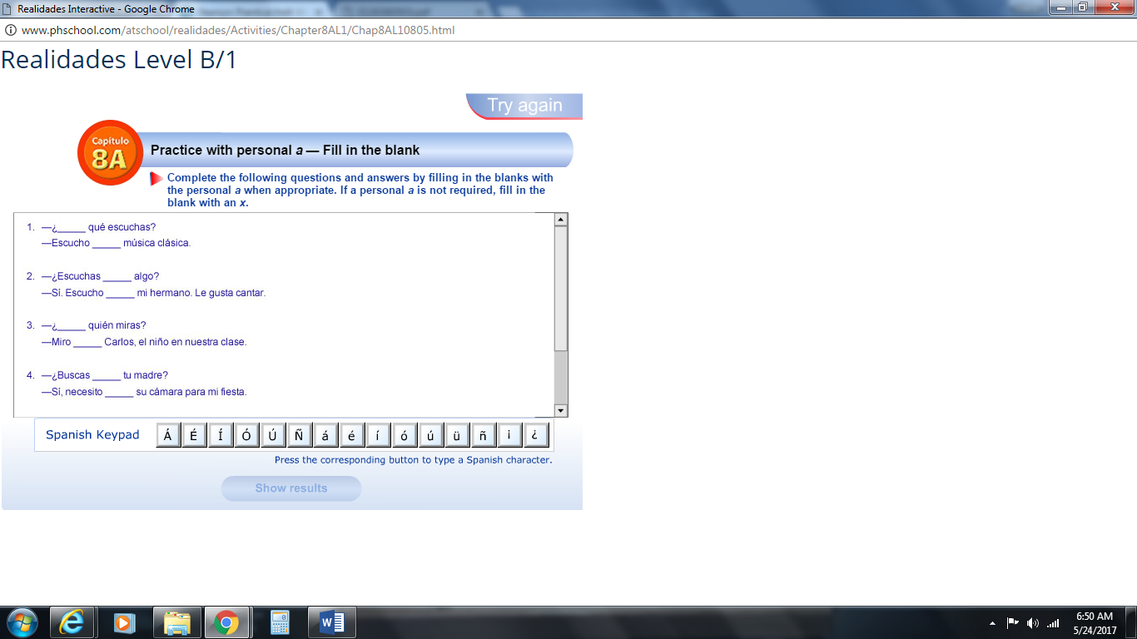

**Pretérito de ir**

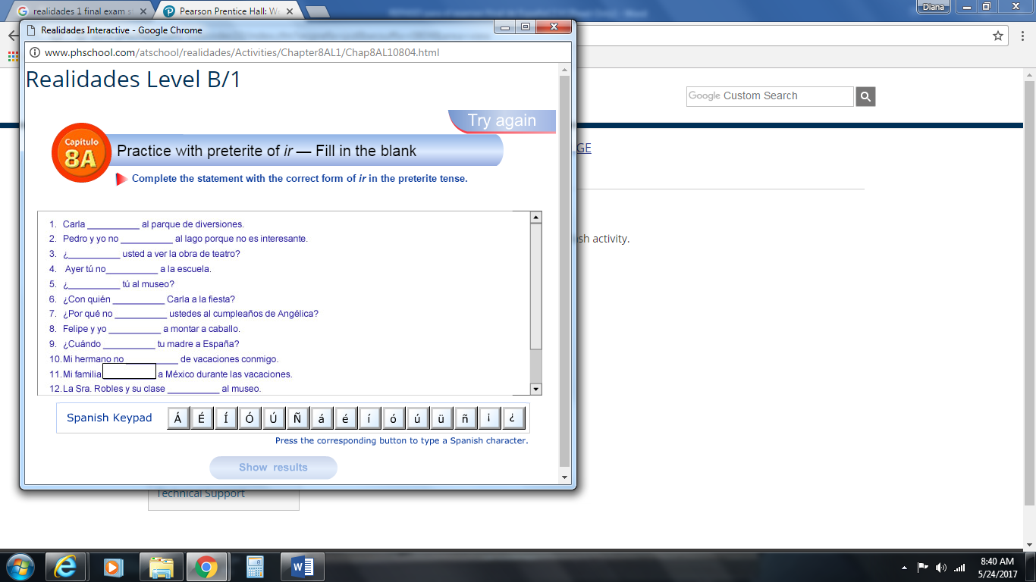

**8 B – Ayudando a la comunidad**

Lugares para trabajar de voluntario Cosas que se reciclan

____________________________ ____________________________

____________________________ ____________________________

____________________________ ____________________________

____________________________ ____________________________

____________________________ ____________________________

____________________________ ____________________________

Para describir experiencias Verbos que hablan de reciclar

_______________________________ _______________________________

_______________________________ _______________________________

_______________________________ _______________________________

La forma del verbo **decir** Los pronombres del objeto indirecto

es: son:

|  |  |  |  |  |
| --- | --- | --- | --- | --- |
| **Singular** | **Plural** |  | **Singular** | **Plural** |
| **Yo** | **Nosotros** |  | **Yo** | **Nosotros** |
| **Tú** | **Ustedes** |  | **Tú** | **Ustedes** |
| **Él/ella** | **Ellos./as** |  | **Él/ella** | **Ellos./as** |

El pretérito del verbo dar es: El pretérito del verbo hacer es:

|  |  |  |  |  |
| --- | --- | --- | --- | --- |
| **Singular** | **Plural** |  | **Singular** | **Plural** |
| **Yo** | **Nosotros** |  | **Yo** | **Nosotros** |
| **Tú** | **Ustedes** |  | **Tú** | **Ustedes** |
| **Él/ella** | **Ellos./as** |  | **Él/ella** | **Ellos./as** |

**Decir**

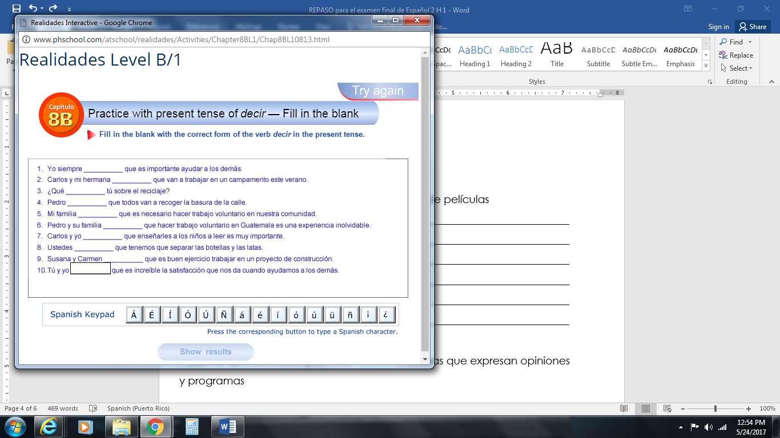

**Dar y Hacer**

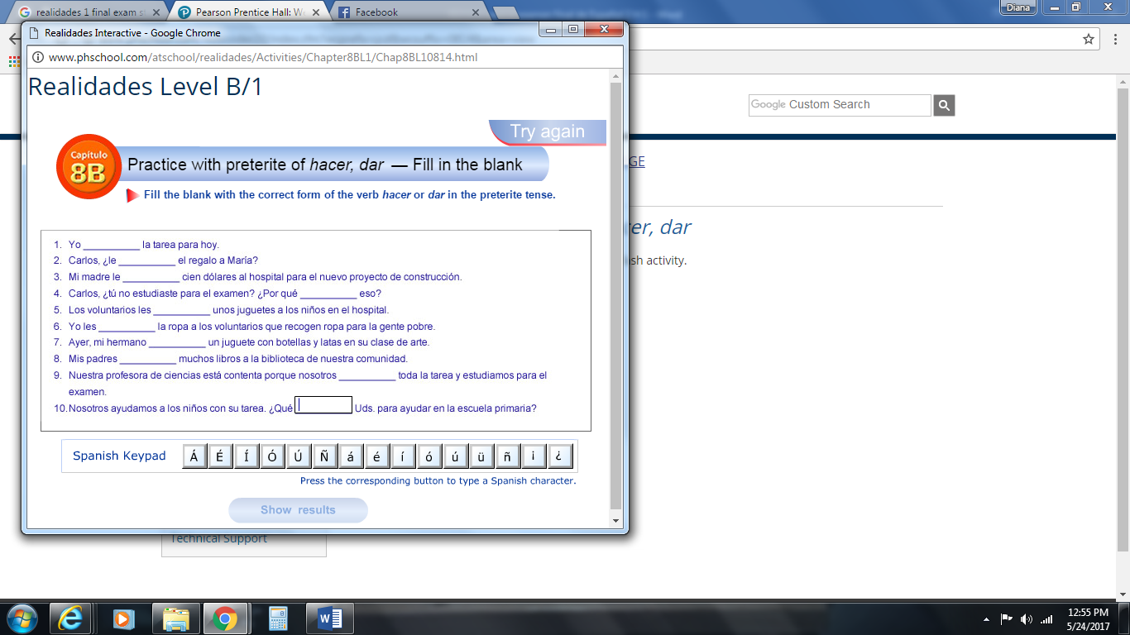

**IOP**

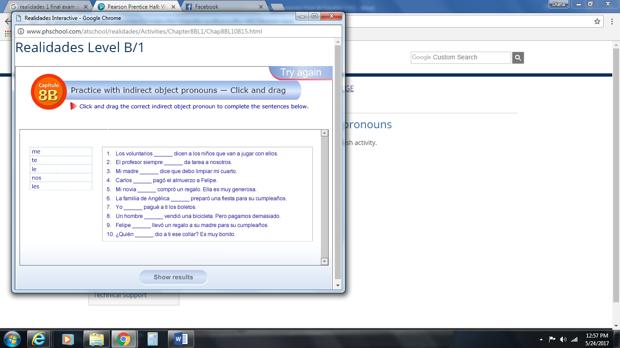

**9A- El cine y la televisión**

Tipos de programas de televisión Tipos de películas

_______________________________ ________________________________

_______________________________ ________________________________

_______________________________ ________________________________

_______________________________ ________________________________

_______________________________ ________________________________

_______________________________ ________________________________

Palabras que describen películas Palabras que expresan opiniones

y programas

_______________________________ _______________________________

_______________________________ _______________________________

_______________________________ _______________________________

_______________________________ _______________________________

_______________________________

1. Se usa ____________ +__________________ para decir que ya algo está terminado.
2. **Me gusta** en inglés es “______________________”. Entonces, la construcción se forma al usar el ______________ primero, luego del verbo ___________ y finalmente _____________.

**Vocabulario**

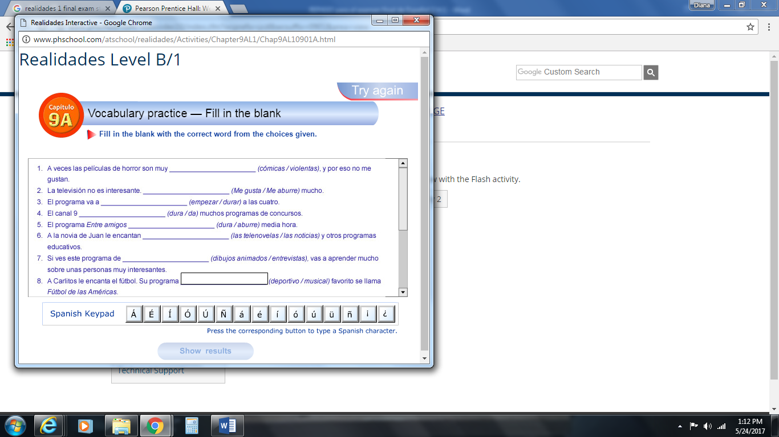

**Acabar de**

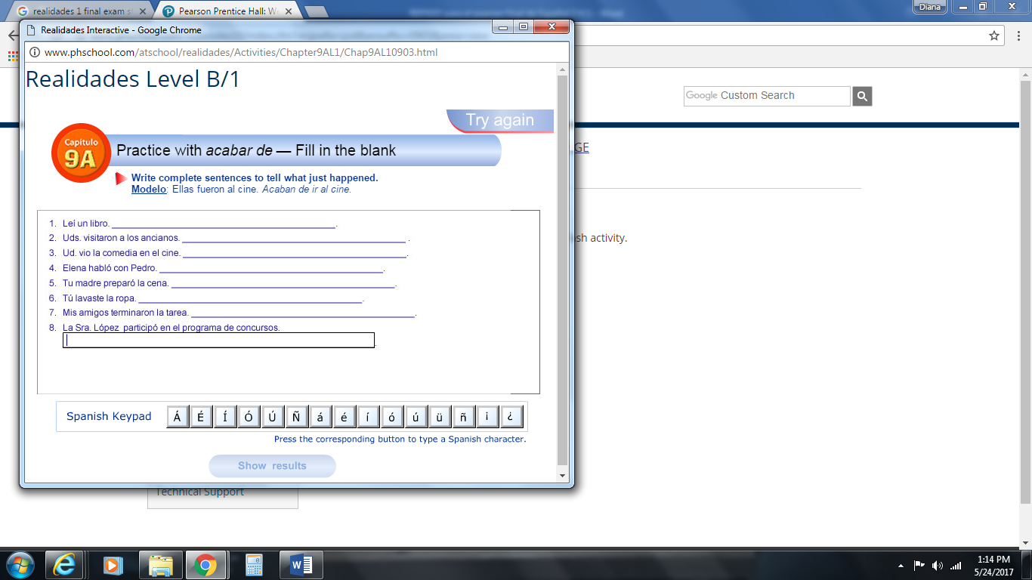

**Verbos como gustar**

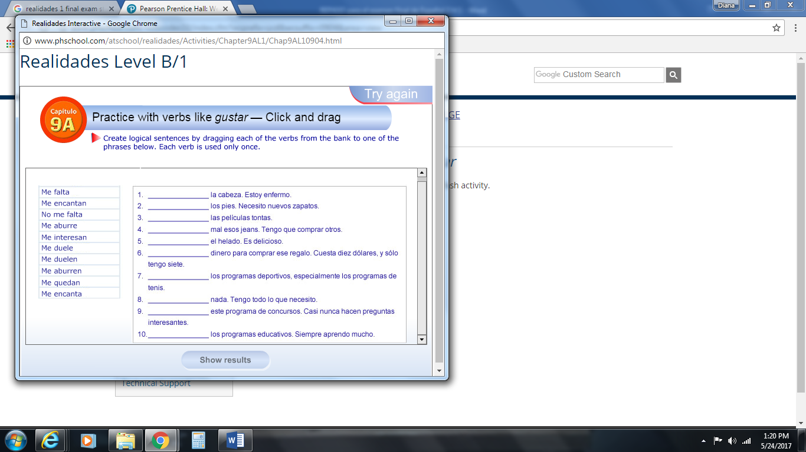

**9B- La tecnología**

Palabras para hablar de la red Palabras de electrónicos

_______________________________ ________________________________

_______________________________ ________________________________

_______________________________ ________________________________

_______________________________ ________________________________

Verbos relacionados con

actividades en línea

_______________________________ _______________________________

_______________________________ _______________________________

_______________________________ _______________________________

La conjugación del verbo La conjugación del verbo

**saber** es: **conocer** es:

|  |  |  |  |  |
| --- | --- | --- | --- | --- |
| **Singular** | **Plural** |  | **Singular** | **Plural** |
| **Yo** | **Nosotros** |  | **Yo** | **Nosotros** |
| **Tú** | **Ustedes** |  | **Tú** | **Ustedes** |
| **Él/ella** | **Ellos./as** |  | **Él/ella** | **Ellos./as** |

La conjugación del verbo en el **futuro**

de los verbos regulares es:

|  |  |
| --- | --- |
| **Singular** | **Plural** |
| **Yo** | **Nosotros** |
| **Tú** | **Ustedes** |
| **Él/ella** | **Ellos./as** |

**Vocabulario**

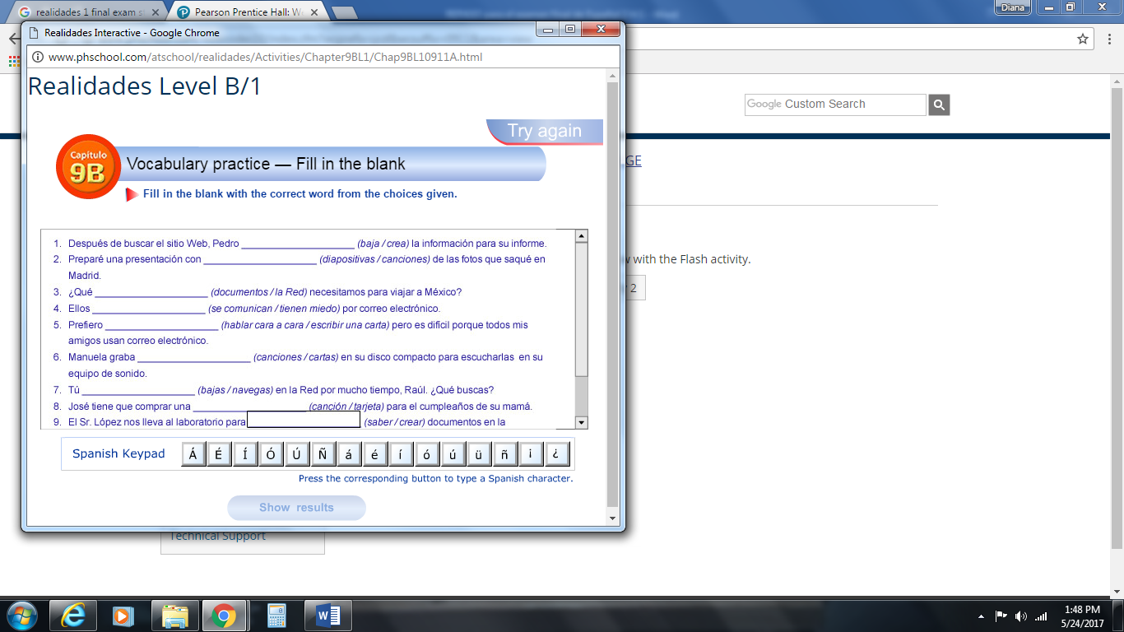

**Saber y Conocer**

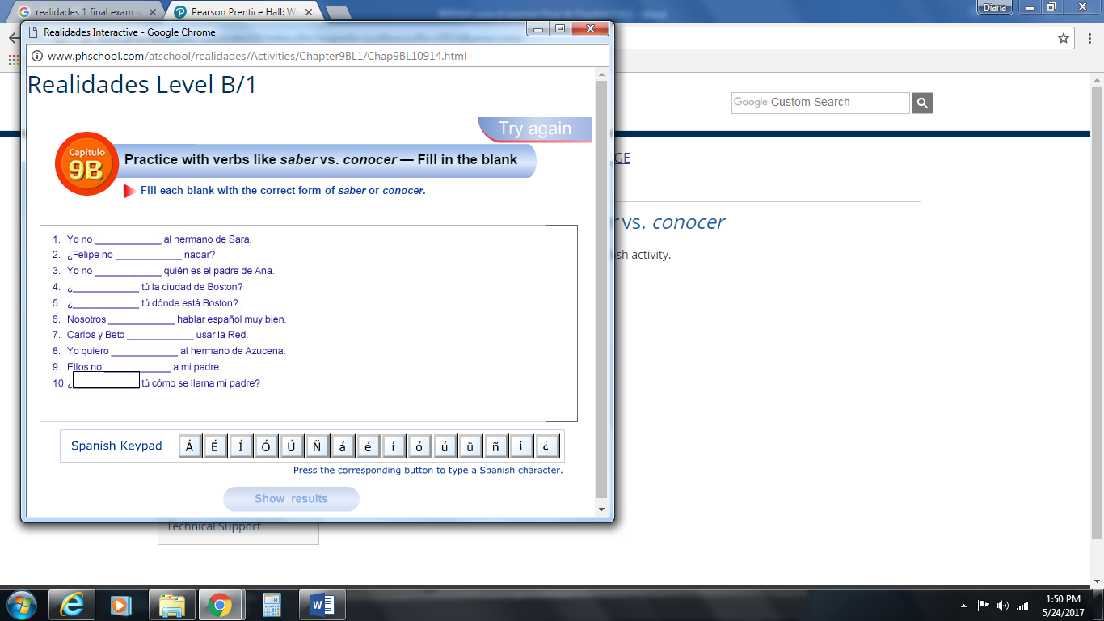

**El futuro**

