Activity 7.1 Scale Model Tower Activity

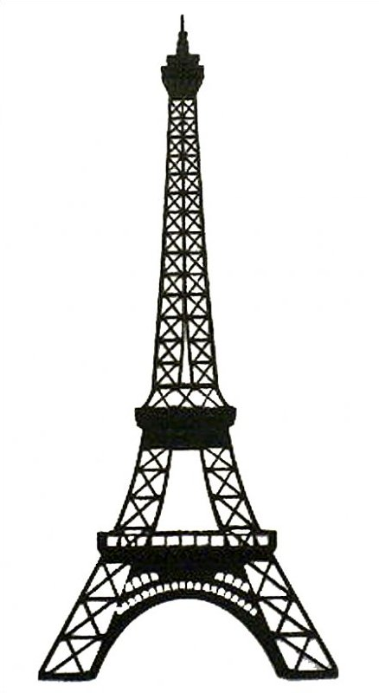

Course: 7th Grade Design and Engineering

Student: _______________________________________________________

Section: _____________________________ Period: _______________

Activity 7.1 Scale Model Tower Activity Design Brief

Background Scenario:

Materials: 20 Wooden Sticks Tools/Equipment: Cutting Tool

Paper Gussets (Unlimited) Abrasive Paper

Wood Glue Wax Paper

Problem Statement: Create the most efficient scale model structure (tower) possible using only the materials, tools and equipment listed above. The completed structure must weigh less than 30 grams. Once the tower is complete, the structure will be weighed to determine its weight.

Parameters:

* The completed structure must be 30 cm tall.
* The completed structure must be within 5 and 7 cm wide.
* The completed structure must weigh less than 30 grams.

Activity 7.1.1 Thumbnail Sketches

Complete 6 Thumbnail Sketches below: (Remember, the first one is completed for you.)

* Use a Ruler
* Use only single lines to represent each of your structural members
* Score each sketch using the 4 point system listed below.

Remember to:

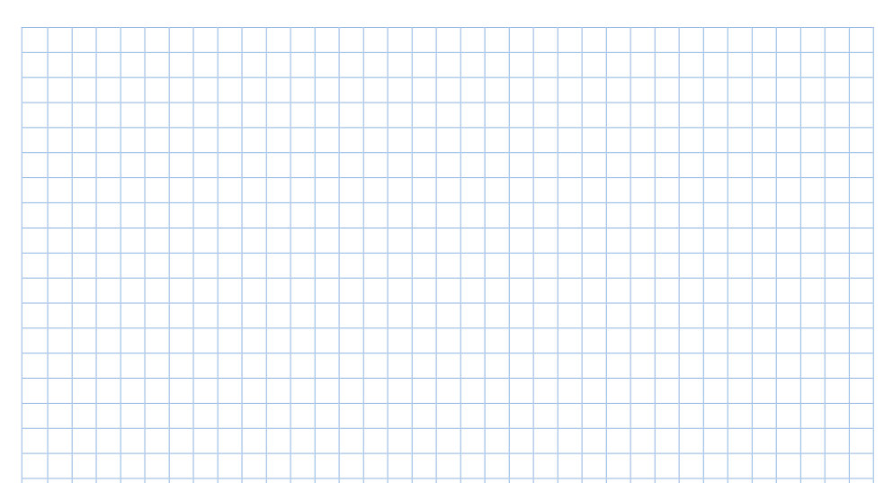

Tower Score = _______

Tower Score = _______

Tower Score = _______



Tower Score = _______

Tower Score = _______

Tower Score = _______

**Scoring Table**

1 pt. – Tower is complete 1 pt. – Tower is using Trusses and/or I-Beams

1 pt. – Tower shows evidence of BALANCE 1 pt. – Tower shows evidence of FLOW

Activity 7.1.2 Rough Sketches

Rough Sketches are more detailed drawings of your idea(s). They are larger than thumbnail drawings and show more detail. From this group of sketches (5), a final design will be chosen.

Procedures: 1) You will need to complete 5 Rough Sketches (one sample has been completed for you). As you can see, rough sketches are drawn: a) with the use of a ruler, and b) drawn with double lines to represent each of the structural members.

2) To complete a rough sketch, you must first complete the structures frame using double lines (2 posts, 2 beams). This “frame” has been completed for you in the first two samples. You will have to complete the frame in each of the boxes on the next page.

3) Next, draw (with ruler) in the number of horizontal beams you want in each design to separate your structure into sections. Your structure may contain only 2 or 3 sections.

4) Finally, draw in the structural members necessary to complete your design idea. *(You may use ideas from the Thumbnail Sketches page or try new ones).*

Complete 5 rough Sketches (2 pages): (Remember, the first one is completed for you.)

* Use a Ruler
* Use **double lines** to represent each of your structural members

Remember to:



Activity 7.1.2 Rough Sketches

Complete 5 rough Sketches:

* Use a Ruler
* Use **double lines** to represent each of your structural members
* Complete the structure’s **FRAME** (2 posts, 2 beams) first!

Remember to:



Activity 7.1.3 Final Drawings (Next Page)

The Final Drawing of an object or idea is the most detailed drawing you will complete and is typically drawn to an exact or scale size. At this point you should have refined your ideas and know which 1 or 2 designs you are going to use.

Procedures: 1) You will need to complete 1 or 2 Final Drawings of your design idea. Final drawings are similar to Rough Sketches but will be drawn to exact scale. As with the Rough Sketches remember to: a) with the use of a ruler, and b) drawn with double lines to represent each of the structural members.

2) Use the procedures outlined in the Rough Sketches section (7.1.2) to drawn each of the Final Drawings on the next page. If you are going to use only 1 design on your structure then you only have to complete one drawing. If you plan on using 2 different design ideas then you will need to complete both drawings.

3) Once your drawing(s) are finished, take your pencil and shade in all of your “sticks”. This step will help you when you get to the actual modeling stage.

Complete Final Drawings: (1 drawing for single design,2 drawings for hybrid)

* Use a Ruler
* Use **double lines** to represent each of your structural members
* Shade in each “stick” with your pencil

Remember to:

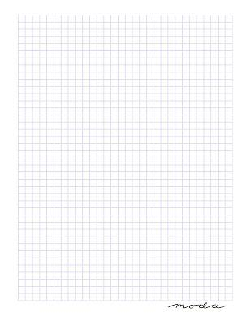

5 cm

6 cm

7 cm

5 cm

6 cm

7 cm