US/WORLD HISTORY

Chapter 8 Section 1

400-405

NAME:______________________ DATE:_____________

**Lesson Objectives**

**1.** **Trace** the reasons that the wartime alliance between the United States and the Soviet Union unraveled.

**2.** **Explain** how President Truman responded to Soviet aggression in Eastern Europe.

**3.** **Describe** the causes and results of Stalin’s blockade of Berlin.

**Academic Vocabulary**

**acknowledge:** to admit or recognize

**appease:** to accept the demands of a person or country even if that action goes against prior principles

**aspiration:** ambition; strong desire to achieve a particular goal

**blockade:** to stop people or supplies from entering a country or city, especially during a war

**dictatorship:** a

**Define the Following Terms:**

satellite state

Cold War

Truman Doctrine

George F. Kennan

Containment

Marshall Plan

Berlin airlift

North Atlantic Treaty Organization (NATO)

Warsaw Pact

iron curtain

**Background of the Cold War: Text**

1. **Compare and Contrast** the United States and the Soviet Union in the late 1940s. As you read “Background of the Cold War,” use the graphic organizer below to take notes about each country’s form of government; political ideology, or beliefs, about citizens’ rights; and philosophy towards the governance of Germany and Eastern Europe.

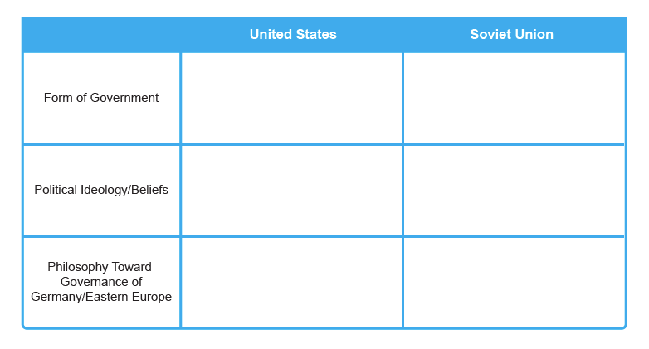

1. **Identify Cause and Effect** Why did Stalin’s actions after World War II lead Truman to believe he was “planning world conquest” after the meeting at Potsdam in 1945?

**3. Summarize** the Truman Doctrine in a sentence or two.

**The United States Contains Soviet Expansion: Text**

**4. Analyze Interactions Among Events** What benefits did the Marshall Plan bring to the United States?

**Soviet Aggression Drives Cold War: Text**

**5. Cite Evidence** Compare the first few “fronts” of the Cold War. Which action was more significant, the Berlin airlift or the U.S. aid to Greece and Turkey? Support your answer with evidence from the text.