**US/World History**

**Chapter 8 Section 2**

**The Korean War**

**406-410**

**Name:__________________ Date:__________**

**Lesson Objectives**

**1.** **Explain** how Mao Zedong and the communists gained power in China.

**2.** **Describe** the causes and the reasons for U.S. involvement in the Korean War.

**3.** **Identify** the long-term effects and outcomes of the Korean War.

**Academic Vocabulary**

**occupation:** a military force’s taking control of a foreign country

**intervene:** to become involved in; to take action to settle a dispute or influence a course of action

**stalemate**: a draw; a competition in which neither player can win or move further

**confront:** to face

**Key Terms**

Jiang Jieshi

Mao Zedong

38th parallel

Douglas MacArthur

limited war

Southeast Asia Treaty Organization (SEATO)

Stalemate

**China Turns Communist: Text**

**1. Determine Central Ideas** As you read “China Turns Communist” and “U.S. Involvement in Korea,” use the problem-solution graphic organizer below to note problems and the steps that President Truman took to solve them.

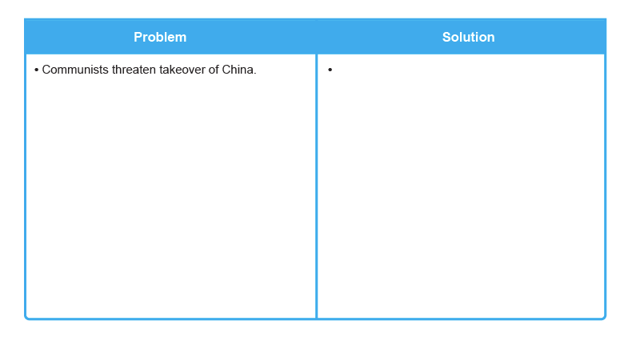

2. Why did the U.S. get involved in the Korean War?

3. What did President Truman and General MacArthur disagree on and what was the result of this disagreement?

5. How did the Korean War end?